**Group 79: Veterinary Hospital Management**

Fall 2021

**Project Final Report**

CPSC 471: Database Management System

Prof. Reda Alhajj

December 24, 2021

**Group Members:**

Heidi Toews (UCID 30094995),

Alisha Lalani (UCID 30123098),

Harsweet Singh (UCID 30117846),

Kusumpreet Kaur Heer (UCID 30114618).

Abstract

Our project centres around creating a website and an app that caters to a Vet Hospital. It not only caters to the clients of the vet hospital, but it is also meant to be used by the employees working at the vet hospital and the admin. There are different levels of hierarchies when it comes to the things accessible to each user. The clients are the ones with client profile which consist of client details which can be edited by the client, pet details, appointment details and shopping history. Questions can be asked by the clients which can be answered by any of the employees. The clients get excess to blog which is posted by the administration and written by the employees and professionals. The employees can view edit their profile details, view their shifts, as well as edit them. They can access all the appointments booked by the clients. They can answer any client questions. The interface allows them to view pet details and edit their medical history. The admins are the ones who can schedule the shifts for the employees, view every employee’s schedule. They can access all client details and delete them. They can also access employee details, and the website allows them to remove or add a new employee. The app allows clients to log in and view their pets, shop in the store, book appointments, and view their upcoming appointments. It also displays the types of appointments and their cost, and some information about the vets that work at the hospital.

Introduction

# The Problem

The problem our system was designed to address is the lack of an all-in-one system for animal hospitals. We found that there isn’t a system for animal hospitals that allows clients to book their own appointments while providing the animal hospital with all the resources they need to run, along with a blog page which answers questions submitted by the users. Currently, most animal hospitals either just have a very basic website where only information and contacts about their hospital is provided. Or either there are websites centered around animal/pet blogs but it is not attached to certain vet hospital which can cater the users in real life too. Which made us realize that there is a need for a web interface/ app which includes all these details. There was a need for an interface which introduces vet hospital clients to a friendly web interface where they can book an appointment easily, and get notified for it. Access contact and location information, along with a web form where they can submit their questions. A online shop which not only displays different pet products, but also recommendations. A blog page which is updated regularly, providing the answers to current topics, or the topics that interest the vets and professionals and also the ones submitted by the user. An interface was required which would provide the client a personal profile page which displayed all their pets and a compilation of their billing history, appointment history, questions they have asked in the past and personalised recommendations.

# Our Solution

Our system allows clients to book their own appointments online, view their upcoming appointments and their pet’s medical history. Clients can also shop for pet supplies online, which shows the billing history in their personal profile page when the order is placed. They can view their pet’s previous appointments and medical information and can add new pet information or can just update or delete the previous ones. The clients can view the blog and contact about the topics they would like to be talked about in the upcoming vlogs. This contact form is available in the contact page, which also displays information about the hospitals contact details and a detailed google map to access the location more precisely. The blogs are written by the vets or the employees, and these blogs are updated and uploaded by the administration or the backend as the blog page is static. The topics that are talked about in the vlog, can be personal topics by the vets or employees or the ones submitted by the users.

Employees of the hospital can view their schedules and are divided into two categories. Administrative staff can view all upcoming client appointments and can book appointments for clients that prefer to book by phone. Vets can view the appointments that clients have booked with them and can view and update medical history for pets associated with these appointments.

Design

# 

# Discussion of Users

There are three main categories of users for our system: clients, employees and admin. Clients can view and manage their profile and their pets profile, they can buy products from the shop, book an appointment, and can ask a question through their profile.

Employees can view and manage their profile, edit their shift time and dates, view and manage their appointment times and dates,view the pets they treat and update their medical history and answer the questions of the clients.

Admin can Edit and Schedule shifts for employees, they can view all the employees scheduled to work on a particular date, they can view all the client, and employee and their information, they can add/sign up new employees to the database.

# 

# ER Diagram

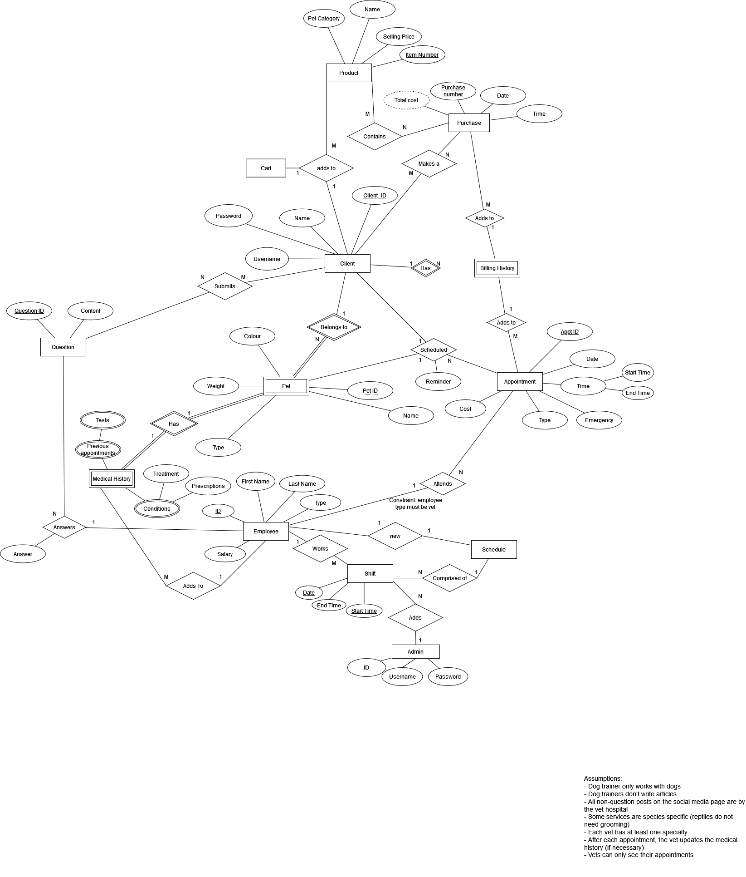

Implementation

# RM Diagram

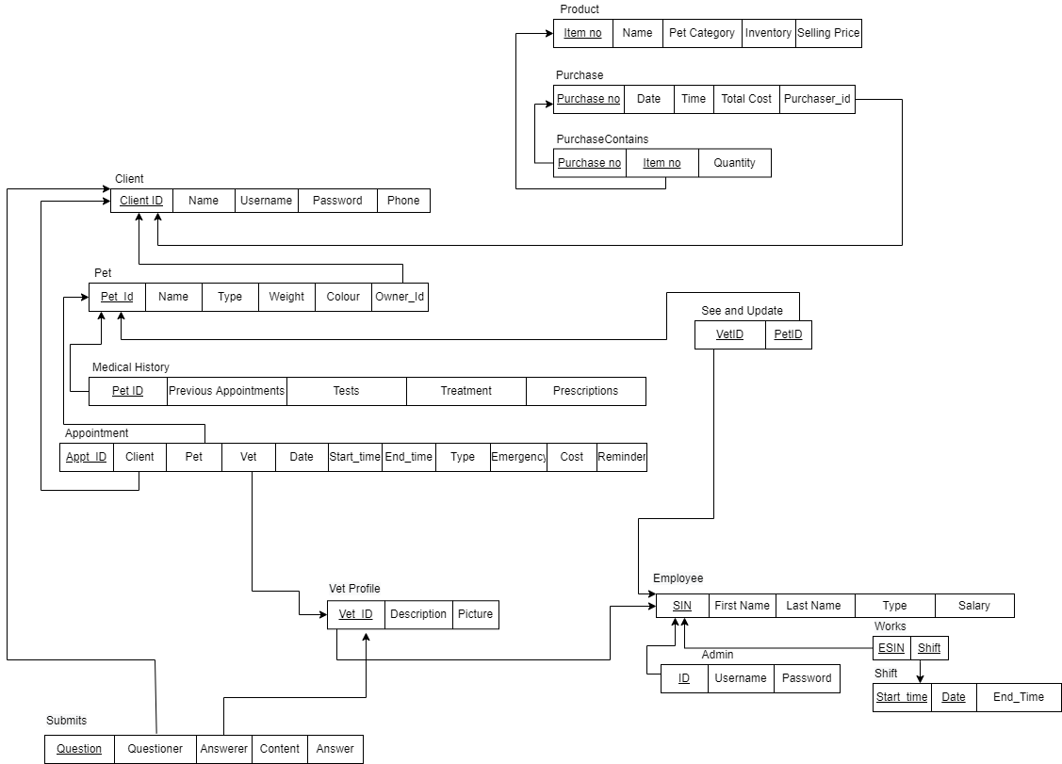

# 

# DBMS chosen & SQL Statements

We chose to use SQL for our DBMS.

The SQL statements we used are:

To add a new client: Inputs are c_name, c_user, and c_pass  
INSERT INTO `client` (`id`, `name`,`username`,`password`) VALUES (NULL, c_name, c_user, c_pass

To delete a client: Input is p_id  
DELETE FROM billinga WHERE billinga.client_ID = p_id;  
DELETE FROM appointment WHERE appointment.client_ID = p_id;  
DELETE FROM cart WHERE cart.client_ID = p_id;  
DELETE FROM billing WHERE billing.client_ID = p_id;  
DELETE FROM question WHERE question.client_ID = p_id;  
DELETE FROM pet WHERE pet.owner_id = p_id;  
DELETE FROM client WHERE id = p_id;

Update client: Inputs are i_id, n_name, n_pass   
UPDATE client set name = n_name, username = n_user, password = n_pass WHERE id = i_id

Get a client: Input is p_id   
SELECT * From client where id = p_id

Add a pet: Inputs are o, n, t, w, c   
INSERT INTO pet (owner_id, name, type, weight, color) VALUES (o,n,t,w,c)

Delete a pet: Inputs are o_id, p_id   
DELETE FROM petMedical WHERE client_ID = o_id AND pet_ID = p_id;  
DELETE FROM billinga WHERE billinga.pet_ID = p_id AND billinga.client_ID = o_id;  
DELETE FROM appointment WHERE appointment.client_ID = o_id AND appointment.pet_ID = p_id;  
DELETE FROM pet WHERE owner_id = o_id AND id = p_id;

Get a pet: Inputs are o_id and p_id   
SELECT * FROM pet WHERE owner_id = o_id AND id = p_id

Update a pet: Inputs are p_ID, o_ID,   
UPDATE pet set name = n, type = t, weight = w, color = c WHERE id = p_ID AND owner_ID = o_ID

Get all pets that belong to a client: Input is c_ID   
SELECT * FROM pet WHERE pet.owner_id = c_ID

Get all pets: No input   
SELECT * FROM pet

Get all clients: No input   
SELECT * FROM client

Add an appointment: Inputs are c_ID, p_ID, apType, v_ID   
INSERT INTO `appointment` (`client_ID`, `pet_ID`,`date`, `time`, `appType`,`vet_ID`) VALUES (c_ID, p_ID, d, t, apType,v_ID)

Get appointments: Input is c_id   
SELECT pet.name as pet_name, apptype.name as appointment_name, pet.id as pet_ID, appointment.client_ID as client_ID, appointment.date, appointment.time From appointment   
JOIN apptype ON apptype.id = appointment.appType  
JOIN pet ON pet.id = appointment.pet_ID  
WHERE appointment.client_ID = c_ID and appointment.date >= CURRENT_DATE  
ORDER BY appointment.date, appointment.time;

Delete an appointment: Inputs are c_id, p_id, d, t  
DELETE FROM appointment WHERE client_ID = c_ID AND pet_ID = p_ID AND date = d AND time = t;

Add a question: Inputs are id, ques, -1  
INSERT INTO `question` (`client_ID`,`question`,`vet_ID`) VALUES (id, ques,-1);

Delete a question: Inputs are c_ID, q_ID   
DELETE FROM question WHERE client_ID = c_ID AND id = q_ID

Get a question: Inputs are c_ID, q_ID   
SELECT * FROM question WHERE client_ID = c_ID AND id = q_ID

Update a question: Inputs are c_ID, q_ID, q, v_ID, a   
UPDATE question SET question = q, vet_ID = v_ID, answer = a WHERE client_ID = c_ID AND id = q_ID

Get unanswered questions: No inputs   
SELECT * FROM question WHERE vet_ID = -1

Get all billing history values for a client: Input is c_id   
SELECT p.name as pet_name, b.*, type.name as appt_name  
FROM billinga as b  
JOIN apptype as type on type.id = b.appType  
JOIN pet as p on p.id = b.pet_ID  
WHERE client_ID = c_ID

Add appointment to client billing history: Inputs are c_ID, p_ID, d, t, apType   
INSERT INTO `billingA` (`client_ID`, `pet_ID`,`date`, `time`, `appType`,`cost`)  
SELECT c_ID, p_ID, d, t, apType, ap.cost  
FROM apptype as ap  
WHERE ap.id = apType

Delete an appointment from client billing history: Inputs are p_ID, c_ID, d, t   
DELETE FROM billingA WHERE pet_ID = p_ID AND client_ID = c_ID AND date = d AND time = t

Get a billing history entry for a client: Inputs are c_ID, d, t  
SELECT p.name as pet_name, b.*, type.name as appt_name  
FROM billinga as b  
JOIN apptype as type on type.id = b.appType  
JOIN pet as p on p.id = b.pet_ID  
WHERE client_ID = c_ID AND b.date = d AND b.time = t

Add a purchase to billing history: Inputs are c_ID, n, q, c, itemP   
INSERT INTO `billing` (`client_ID`, `name`,`timeStamp`,`quantity`, `cost`,`itemPrice`)  
VALUES (c_ID, n, now(), q, c, itemP)

Get purchases from billing history: Input is c_ID   
SELECT * FROM billing WHERE client_ID = c_ID

Add an item: Inputs are n, p, img, t, c  
INSERT INTO item (name, price, image, times_purchased, category) VALUES (n,p,img,t,c)

Delete an item: Input is i_ID   
DELETE FROM item WHERE item.id = i_ID

Get all items: No inputs   
SELECT i.name as item_name, i.price, i.id,i.image, i.times_purchased, c.name as category FROM item as i  
JOIN category as c on c.id = i.category

Update an item: Inputs are n_name, n_price, p, img, i_id   
UPDATE item set name = n_name, price = n_price, times_purchased = p, image = img WHERE id = i_id

Get the top three best sellers: No inputs   
SELECT i.name, i.price, i.image, c.name as category   
FROM item as i  
JOIN category as c on c.id = i.category  
ORDER BY i.times_purchased DESC  
LIMIT 3

Get all items in a category: Input is c   
SELECT i.*, c.name as category FROM item as i  
JOIN category as c on c.id = i.category  
WHERE i.category = c  
ORDER BY i.category

Update an admin: Inputs are vf_name, vl_name, v_user, v_pass, v_ID   
UPDATE admin set f_name = vf_name, l_name = vl_name, username = v_user, password = v_pass WHERE id = v_ID

Get all receptionists: No inputs   
SELECT vet.*, type.name as type, type.id as type_ID FROM vet  
JOIN vettype as type on type.id = vet.type  
WHERE vet.type = 1

Get all vets: No inputs   
SELECT vet.*, type.name as type, type.id as type_ID FROM vet  
JOIN vettype as type on type.id = vet.type  
WHERE vet.type = 0

Delete medical history for a pet: Inputs are c_ID, p_ID   
DELETE FROM petMedical WHERE client_ID = c_ID AND pet_ID = p_ID

Add medical history for a pet: Inputs are c_ID, p_ID, d   
INSERT into petmedical (client_ID, pet_ID, description, date) VALUES (c_ID, p_ID, d, CURRENT_TIMESTAMP)

Get cart for a client: Input is c_ID   
SELECT c.*, cat.name as category_name, cat.id as category_ID, i.* FROM cart AS c  
INNER JOIN item as i on c.item_ID = i.id  
JOIN category as cat on cat.id = i.category  
WHERE client_ID = c_ID

Get quantity of an item in a client’s cart: Inputs are c_ID, i_ID   
SELECT quantity FROM cart WHERE client_ID=c_ID AND item_ID=i_ID

Add to a client’s cart: Inputs are c_ID, i_ID, q  
INSERT INTO `cart` (`client_ID`, `item_ID`,`quantity`) VALUES (c_ID, i_ID, q)

Delete an item from a client’s cart: Inputs are c_ID, i_ID   
DELETE FROM cart WHERE client_ID = c_ID AND item_ID = i_ID

Update quantity in cart: Input is q  
UPDATE cart set quantity = q WHERE client_ID = c_ID AND item_ID = i_ID

Empty cart: Input is c_ID   
DELETE FROM cart WHERE client_ID = c_ID

Add and employee: Inputs are vf_name, vl_name, v_type, v_user, pass   
INSERT INTO `vet` (`f_name`, `l_name`, `type`, `username`, `password`) VALUES (vf_name, vl_name, v_type,v_user,pass)

Delete an employee: Input is v_SIN   
DELETE FROM shift WHERE shift.vet_ID = v_SIN;  
DELETE FROM question WHERE question.vet_ID = v_SIN;  
DELETE FROM vet WHERE vet_ID = v_SIN;

Get an employee: Input is v_SIN   
SELECT * FROM vet WHERE vet_ID = v_SIN

Update an employee: Inputs are vf_name, vl_name, v_user, v_pass, v_ID   
UPDATE vet set f_name = vf_name, l_name = vl_name, username = v_user, password = v_pass WHERE vet_ID = v_ID

Add a shift for an employee: Inputs are v_ID, d, s, e  
INSERT INTO `shift` (`vet_ID`, `date`, `start_time`, `end_time`) VALUES (v_ID, d, s, e)

Get upcoming shifts for an employee: Input is v_ID   
SELECT * FROM shift WHERE vet_ID = v_ID AND shift.date >= CURRENT_DATE

Get all employees working on a date: Input is d   
SELECT vet.f_name, vet.l_name, s.start_time, s.end_time FROM vet  
JOIN shift AS s ON s.vet_ID = vet.vet_ID  
WHERE s.date = d

Add an appointment: Inputs are c_ID, p_ID, d, t, apType, v_ID   
INSERT INTO `appointment` (`client_ID`, `pet_ID`,`date`, `time`, `appType`,`vet_ID`) VALUES (c_ID, p_ID, d, t, apType,v_ID)

Delete an appointment: Inputs are c_ID, p_ID, d, t   
DELETE FROM appointment WHERE client_ID = c_ID AND pet_ID = p_ID AND date = d AND time = t

Get all appointments on a date: Inputs are d   
SELECT pet.name as pet_name, apptype.name as appointment_name, pet.id as pet_ID, appointment.client_ID as client_ID, appointment.date, appointment.time From appointment   
JOIN apptype ON apptype.id = appointment.appType  
JOIN pet ON pet.id = appointment.pet_ID  
WHERE appointment.date = d  
ORDER BY appointment.date, appointment.time

# API Documentation

Appointment:   
<https://documenter.getpostman.com/view/18441878/UVREijGj>

Available Appointment TImes:   
<https://documenter.getpostman.com/view/18441878/UVREijGk>

Best Seller:   
<https://documenter.getpostman.com/view/18441878/UVREijGm>

Billing (Appointments):   
<https://documenter.getpostman.com/view/18441878/UVREijGn>

Billing (Products):   
<https://documenter.getpostman.com/view/18441878/UVREijGo>

Cart:   
<https://documenter.getpostman.com/view/18441878/UVREijGp>

Client:   
<https://documenter.getpostman.com/view/18441878/UVREijGq>

Employee:   
<https://documenter.getpostman.com/view/18441878/UVREijGr>

Get Receptionists:   
<https://documenter.getpostman.com/view/18441878/UVREijGs>

Get Vets:   
<https://documenter.getpostman.com/view/18441878/UVREijGt>

Item:   
<https://documenter.getpostman.com/view/18441878/UVREijM9>

Medical History:   
<https://documenter.getpostman.com/view/18441878/UVREijMA>

Pet:   
<https://documenter.getpostman.com/view/18441878/UVREijMB>

Question:   
<https://documenter.getpostman.com/view/18441878/UVREijMC>

Shift:   
<https://documenter.getpostman.com/view/18441878/UVREijMD>

Unanswered Question:   
<https://documenter.getpostman.com/view/18441878/UVREijME>

User Guide

# Website

1. **Client Login**

Existing users can log into their accounts using their account username and password.

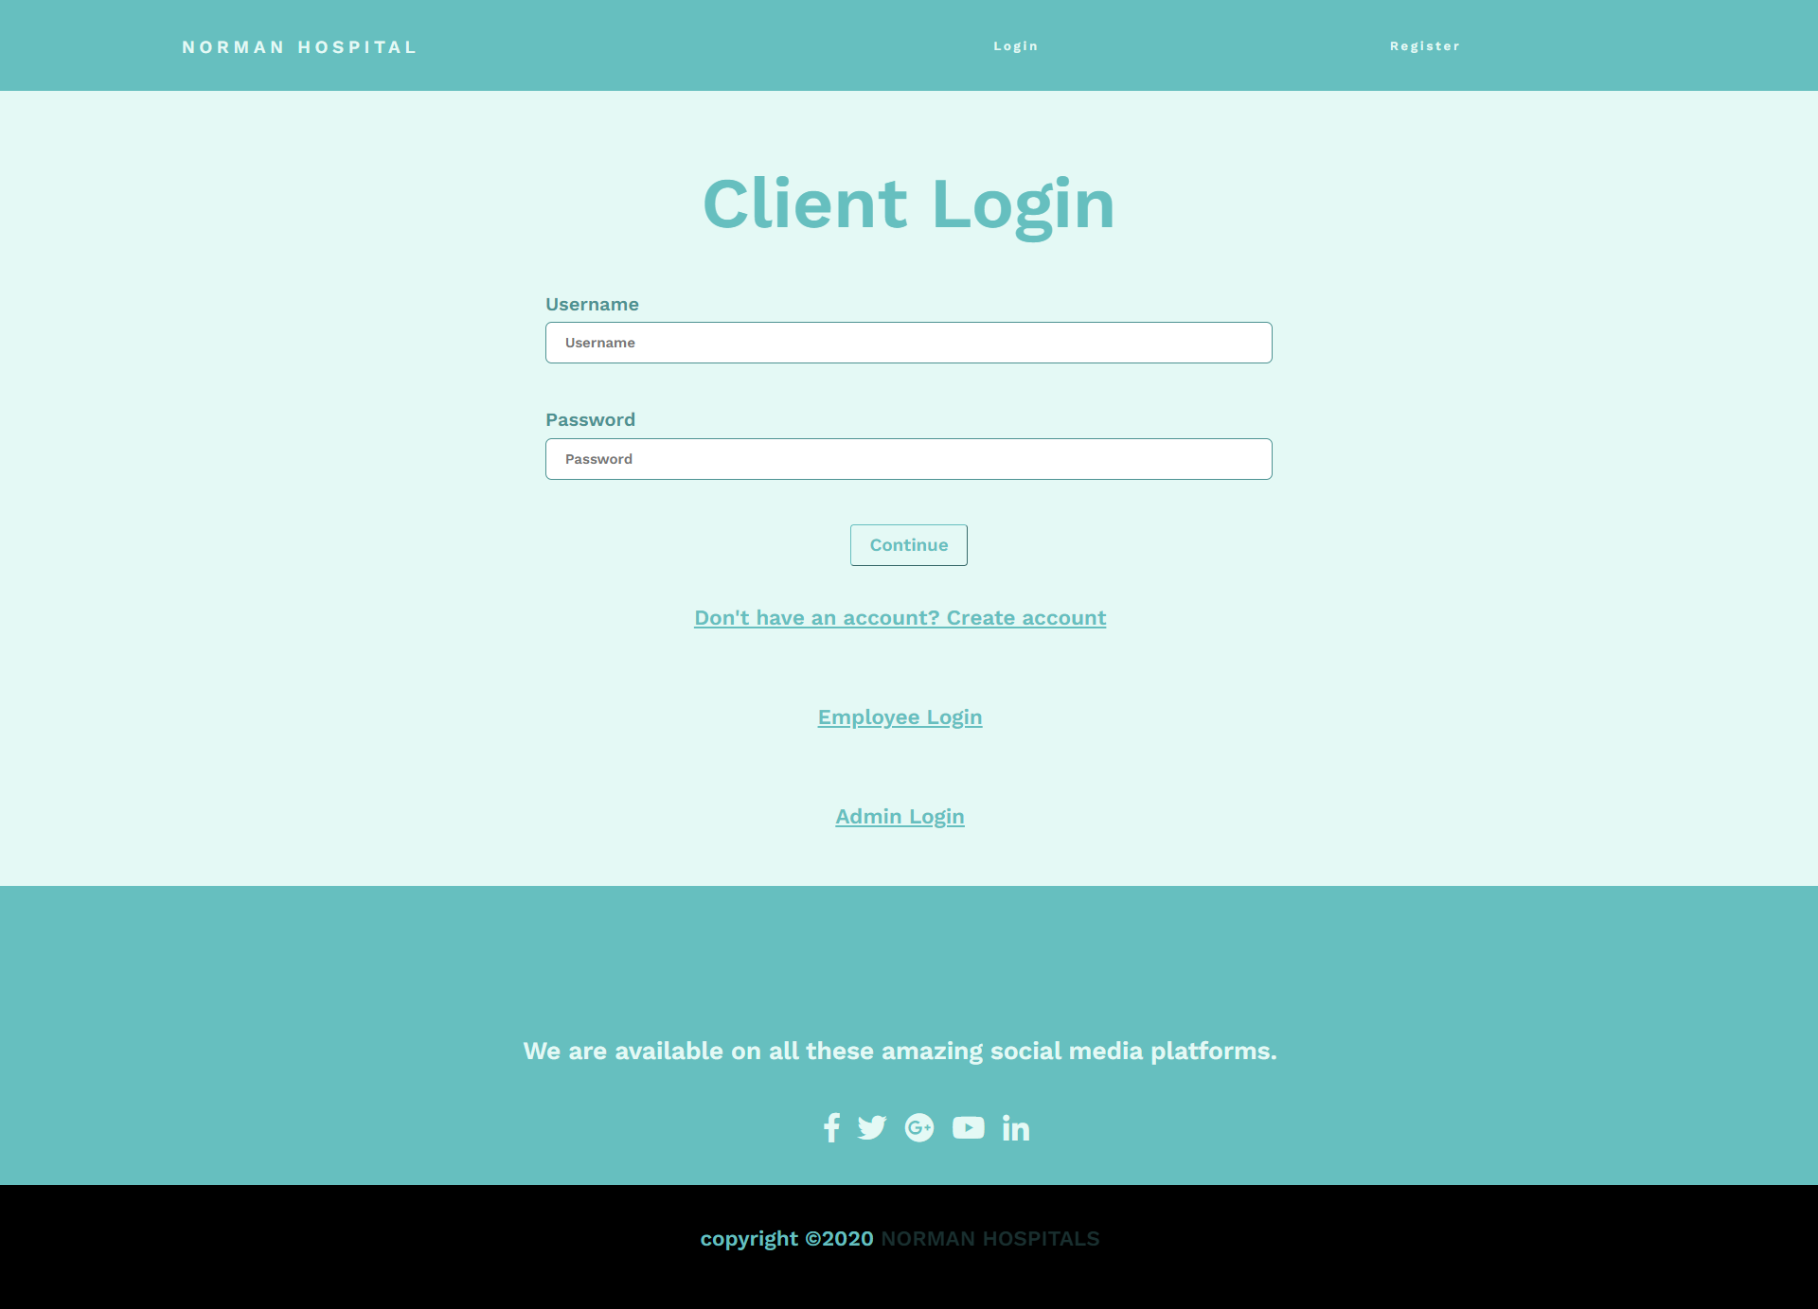

1. **Client Profile**

After the client logs in, the continue button redirects to the client Profile page. It has the following functionalities:

* Appointment notification
* User details
* Pet details, personalized notification for each pet.
* Products Bought
* Services Bought
* Upcoming Appointment
* User Questions

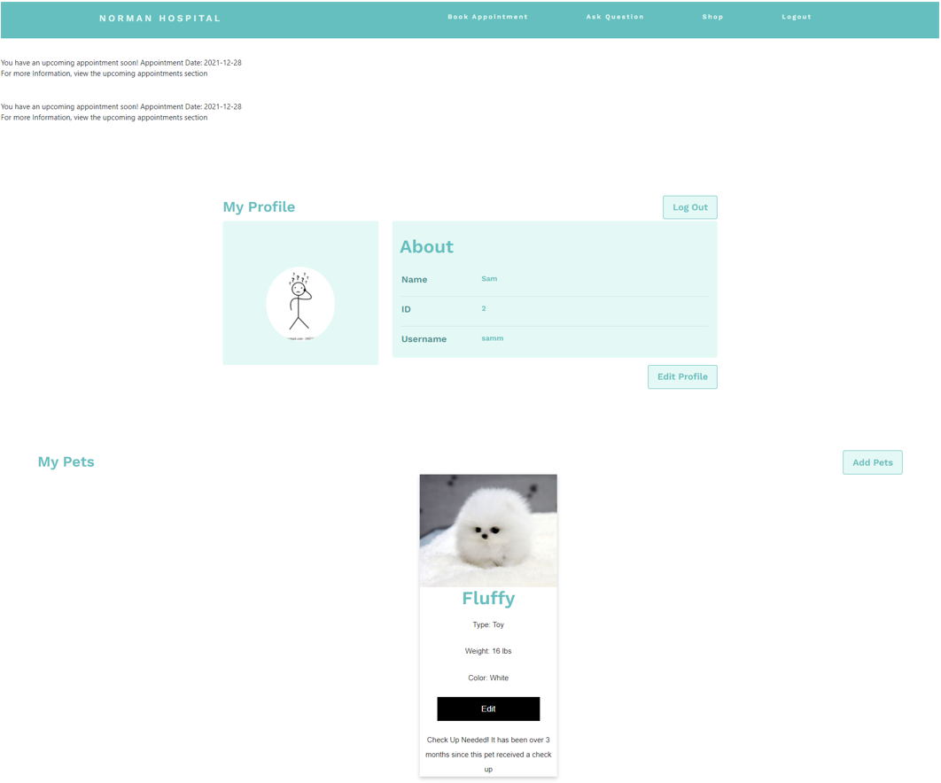

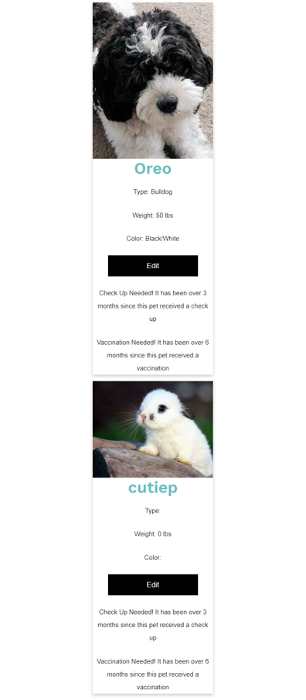

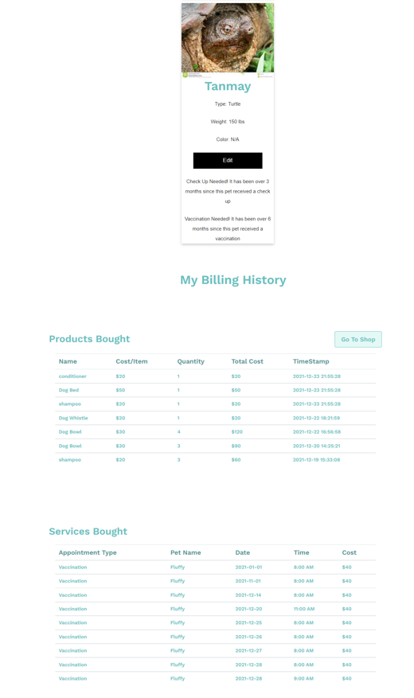

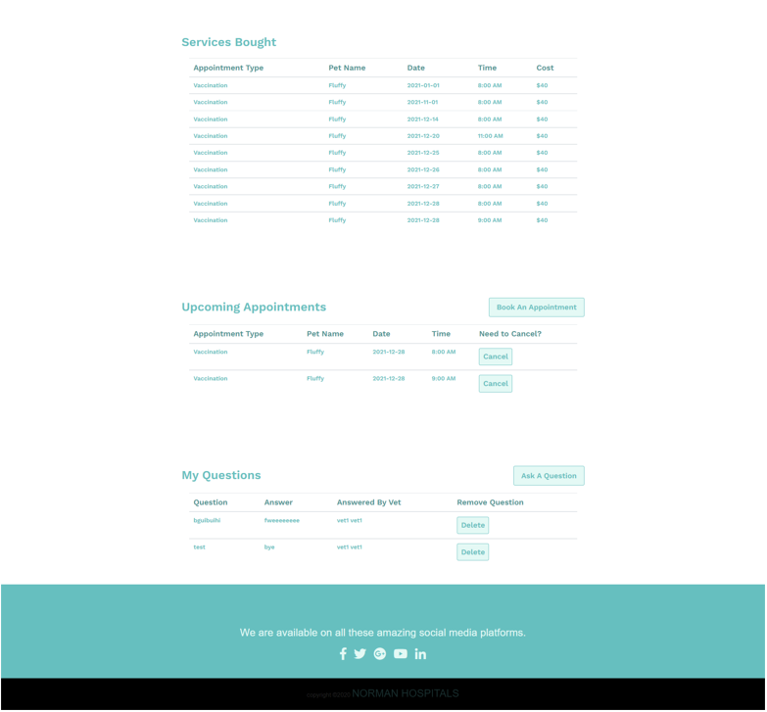

**i.) Edit Profile Button**

It redirects us to the Edit Client Profile page, where the users can edit name, username and password. The user can also upload/change a profile picture.

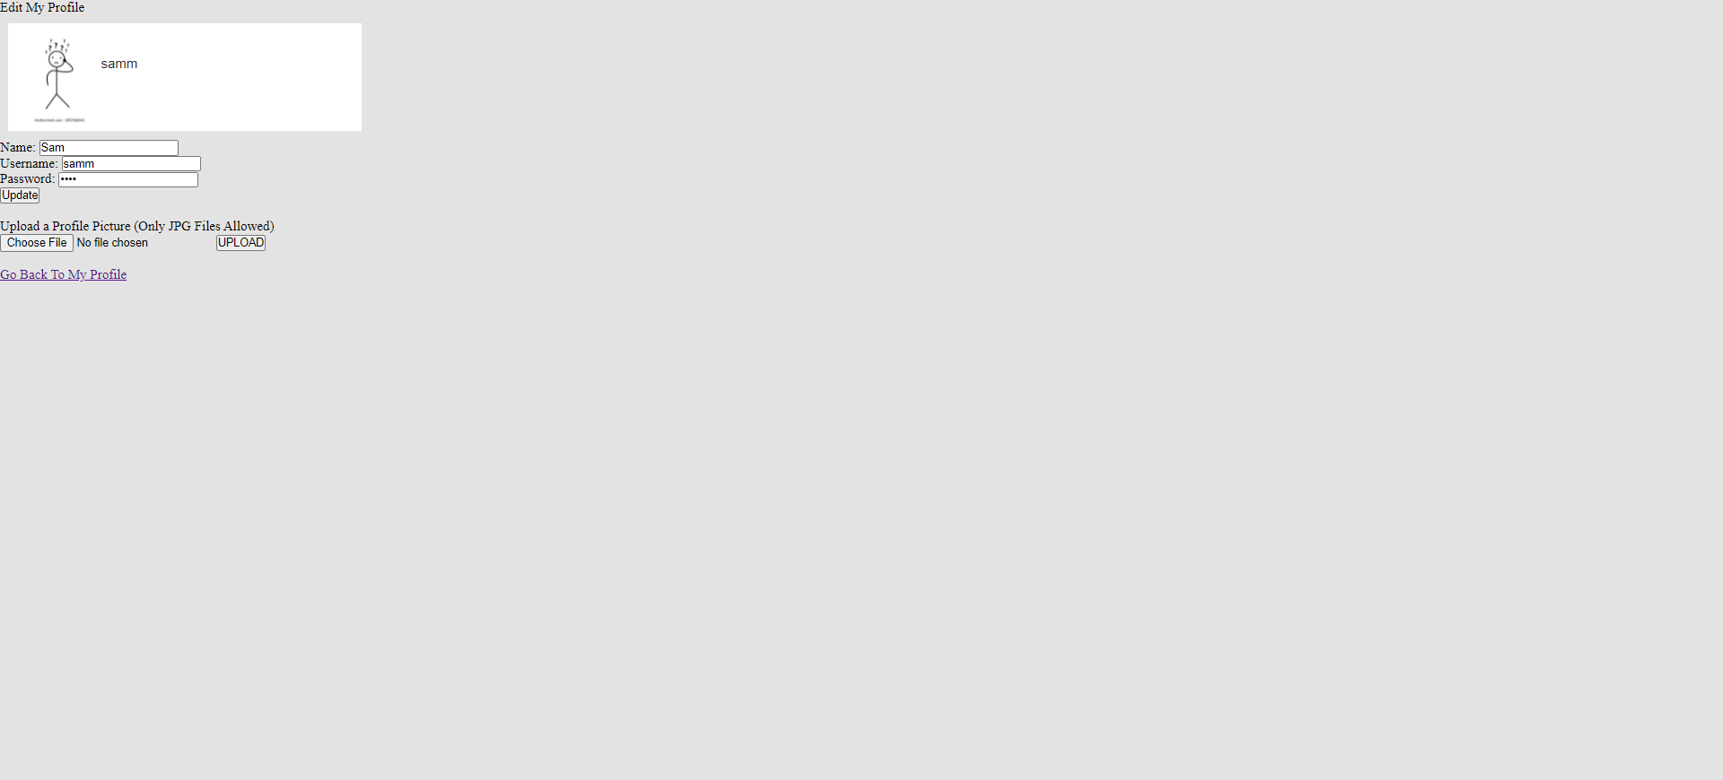

**ii.) Add Pet Button**

This button is used to add a new pet on the user profile page by the user.

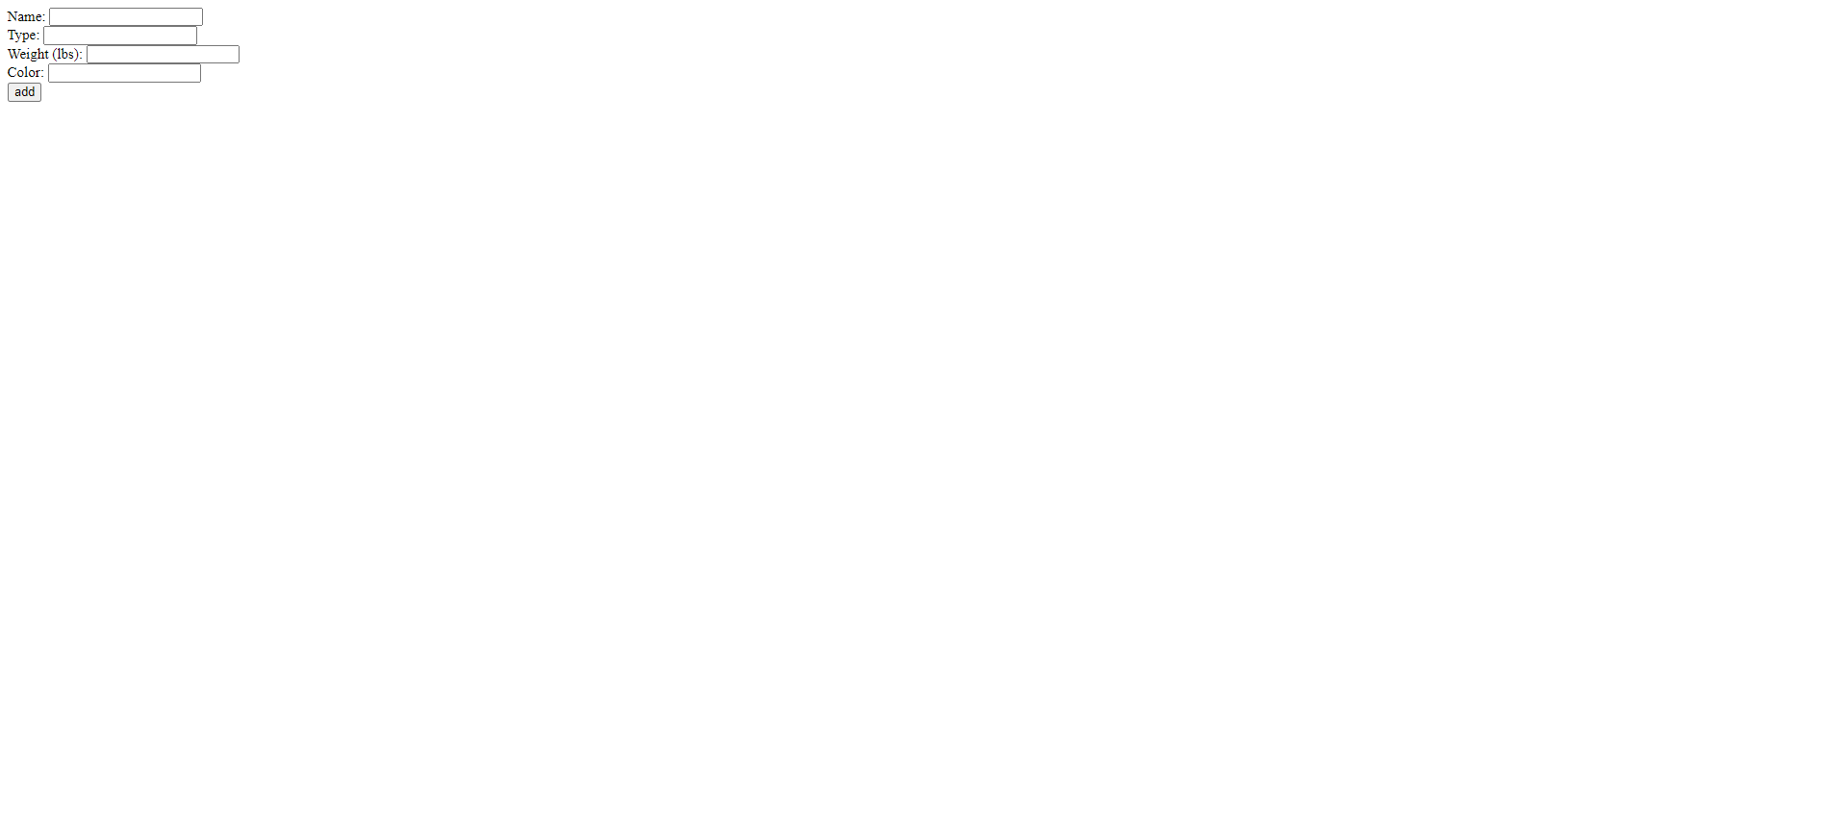

**iii.) Edit Pet Button**

This button is used to Edit pet details, such as Name, type, weight, color. The user can also upload/change a profile picture for the pet.

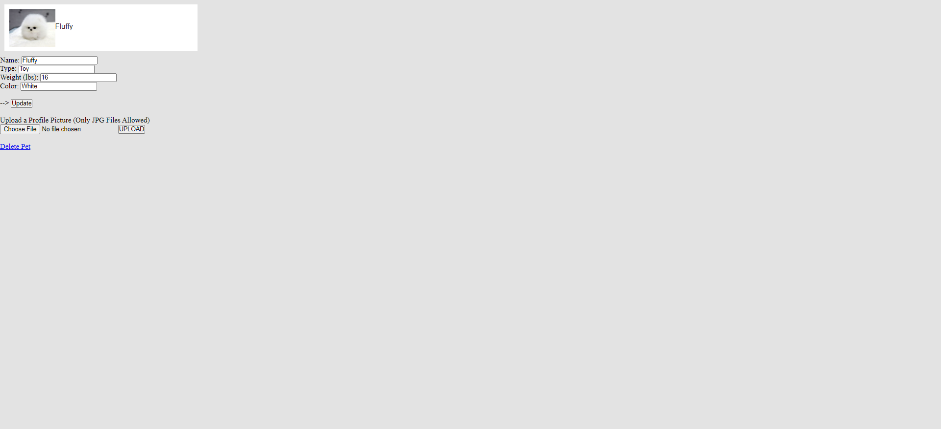

**iv.) Go To Shop Button**

This button redirects the user to the shop, where products can be added to the cart using add to cart button.

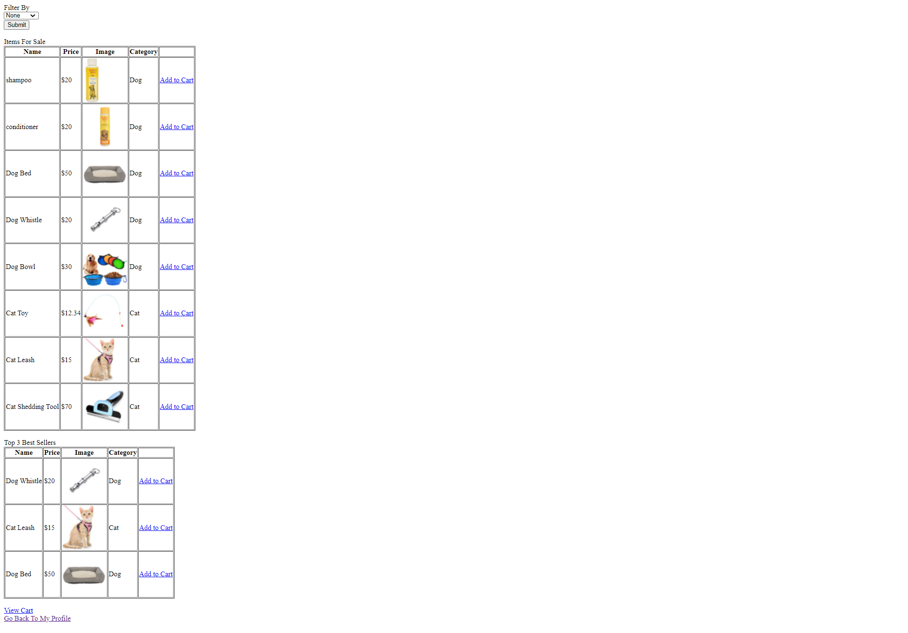

**iv.1.) Filter By**

This drop down is used to filter products by the pet type, which includes, Dog, Cat and Hamster.

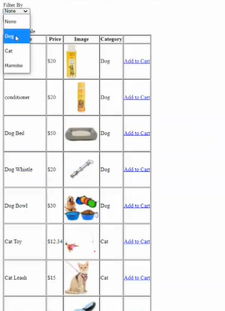

**iv.2.) After using the Filter**

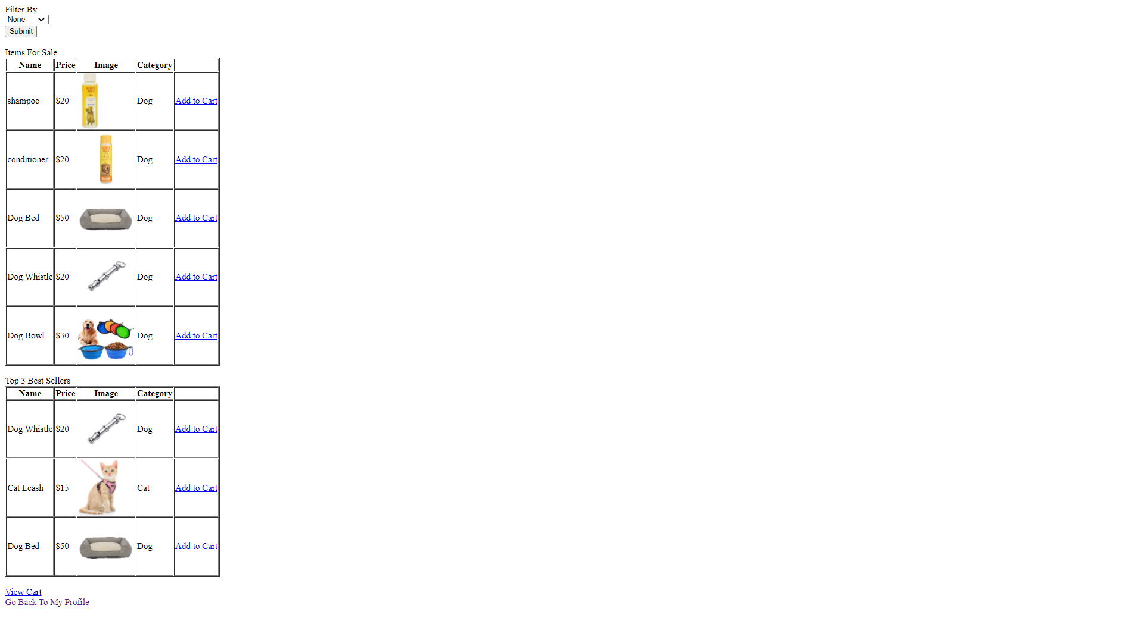

**iv.3.) View Cart Button**

View Cart button recirects us to the cart page, where all the products added to the cart can be viewed, where the items in the cart can be removed and the quantity can be altered. Back to shop button would redirect us to the shop and Checkout button would lead to check out and and the product details would be added to product bought in client profile.

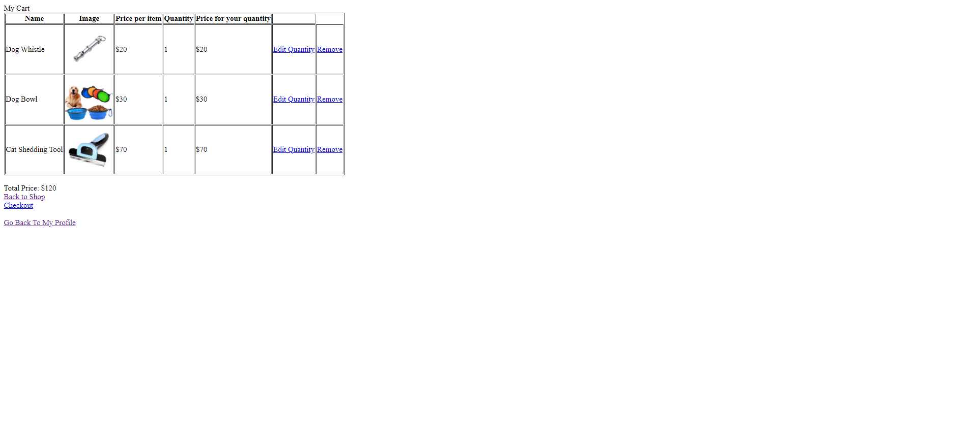

**v.) Boot An Appointment Button**

This button redirects us to the appointment page, where appointments can be booked by the user.

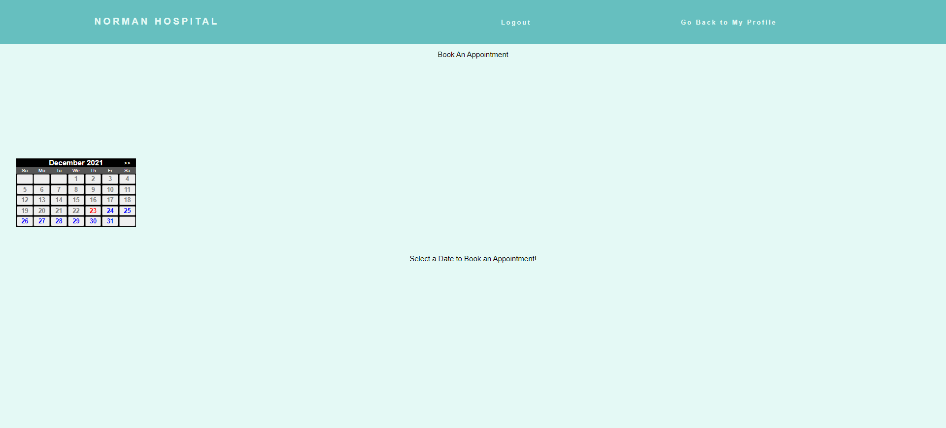

When a desired date is chosen, further options are available to choose a required time, pet and appointment type.

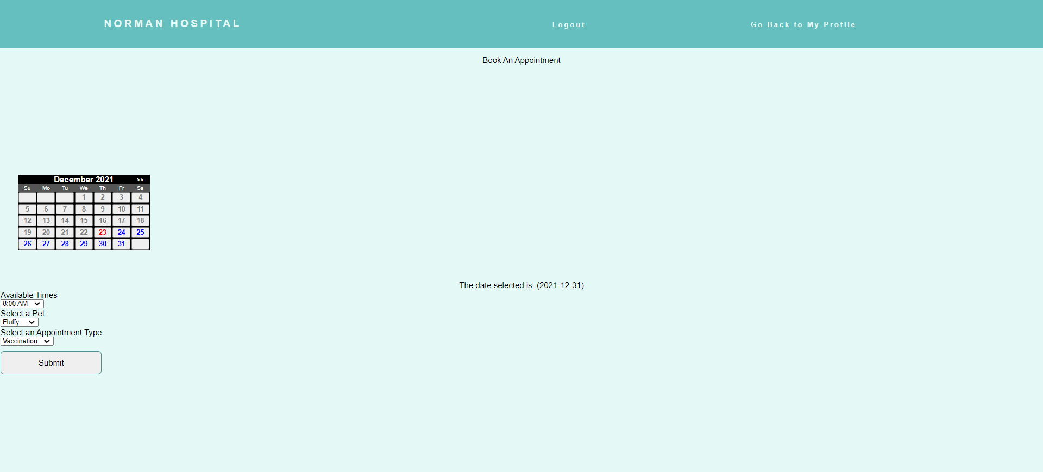

**vi.) Ask a Question Button**

This button redirects us to page where questions can be submitted using the form, it also displays the contact details and location details of the hospital.

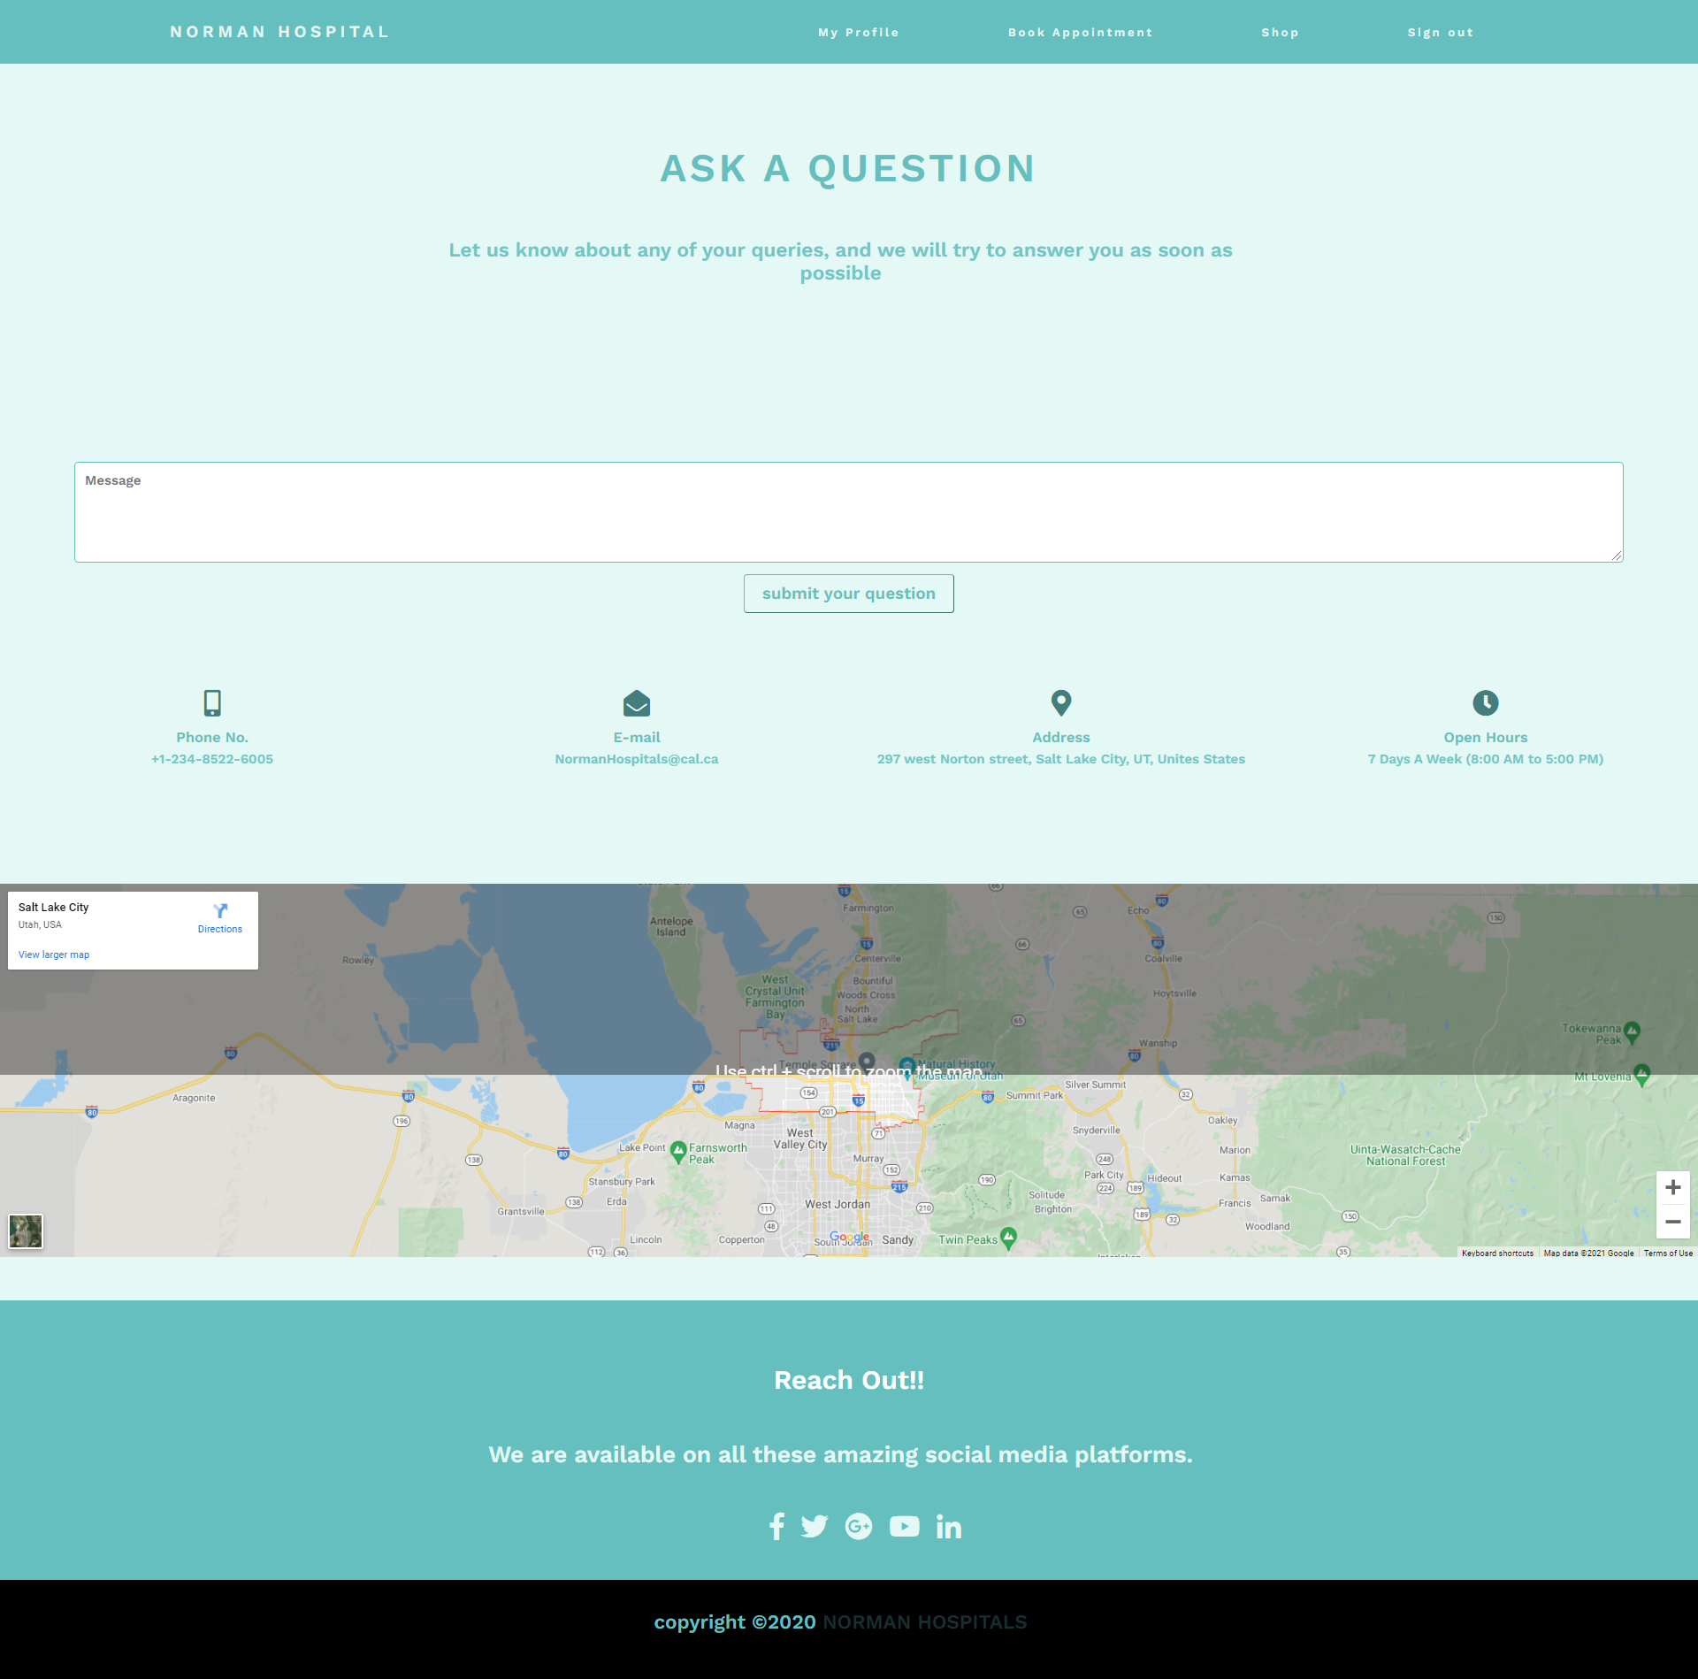

1. **Client Signup**

New clients can sign up for a new account using their Name, Username and Password.

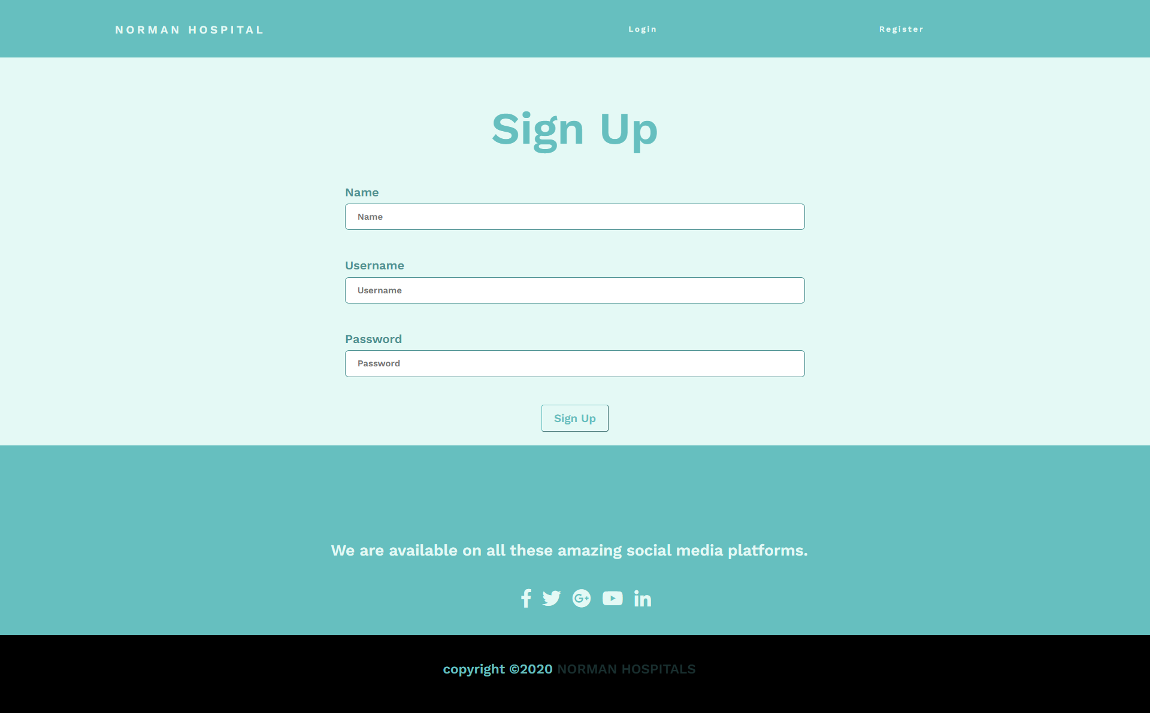

1. **Employee Login**

Existing Employee can log in to their account from the employee login page, using thier Username and password.

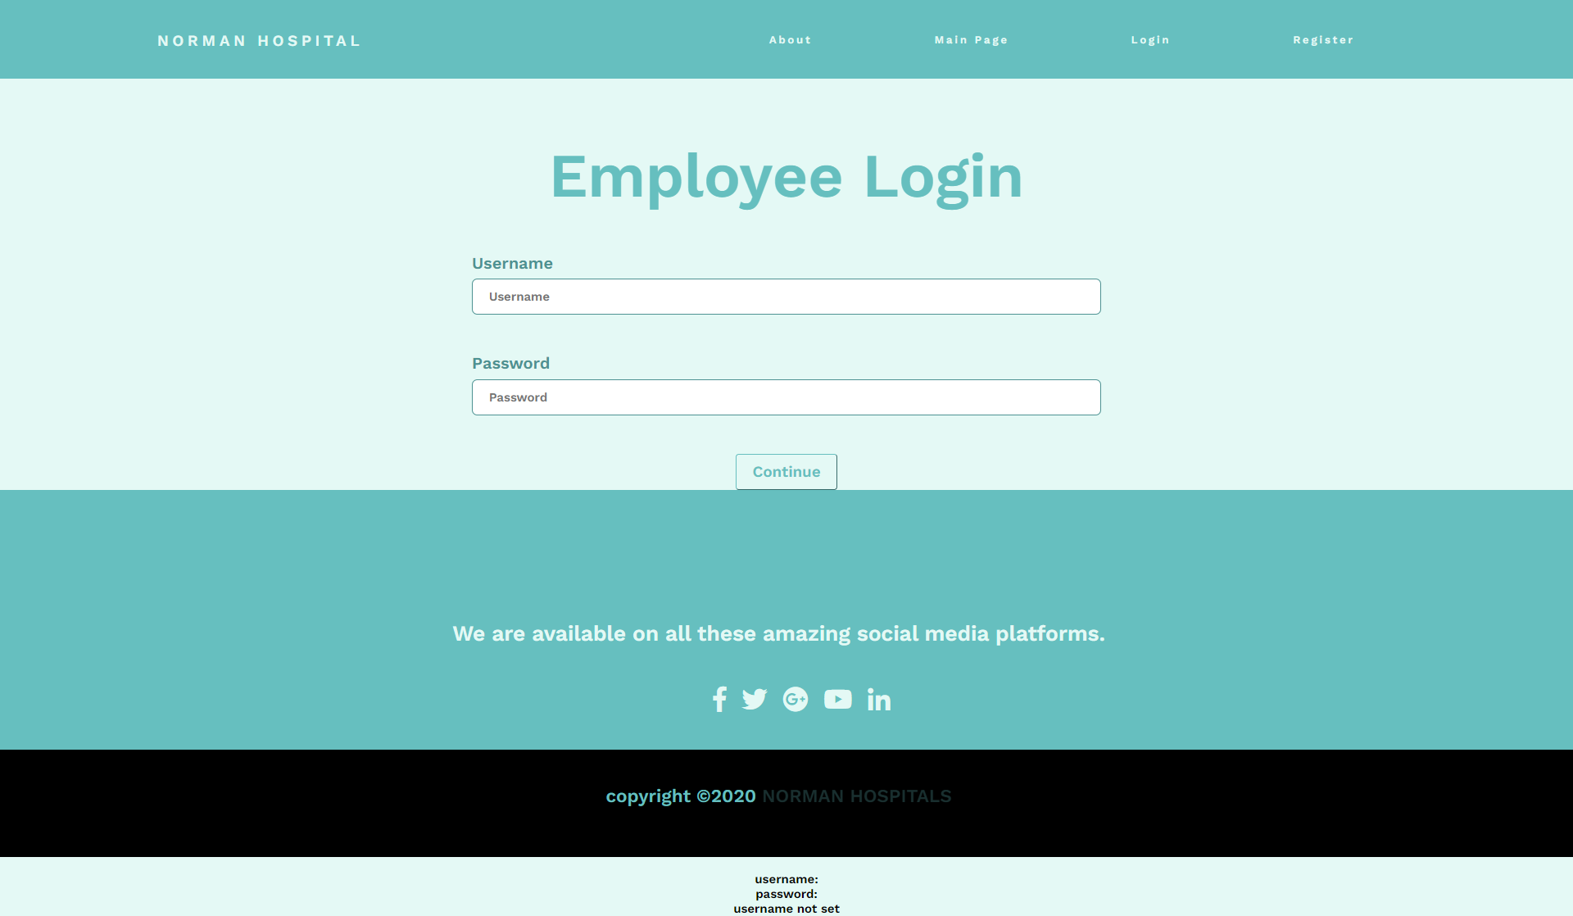

1. **Employee Profile Page**

When the correct username and password is used, the continue button redirects us to the front page for employee login, unanswered questions can be viewed and answered usng he unanswered question table.

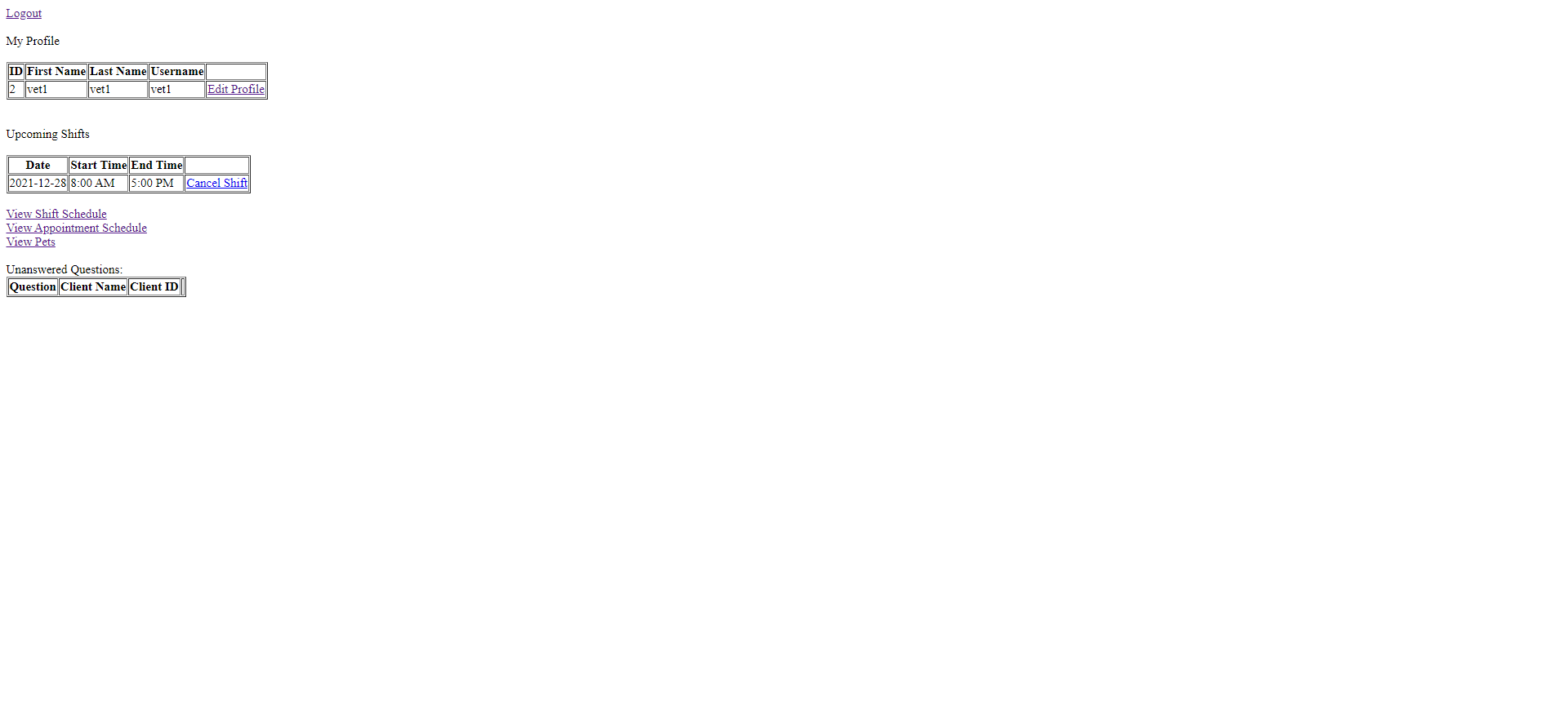

**i.) Edit Profile Button**

This button redirects us to the page where details like, First Name, Last Name, Username and Password can be changed.

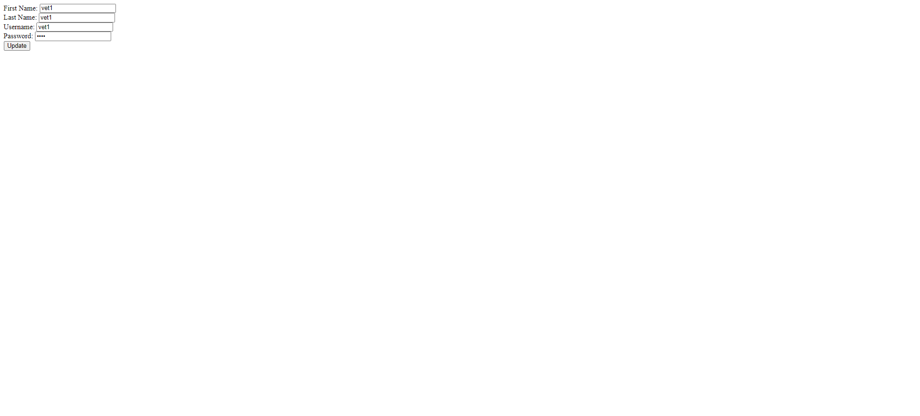

**ii.) Cancel Shift Button**

This button can be used to delete the shift for that particular employee.

**iii.) View Shift Schedule Button**

This button redirects the employee to a page where they can view their shift schedule for a particular date. A date from the calendar can be selected.

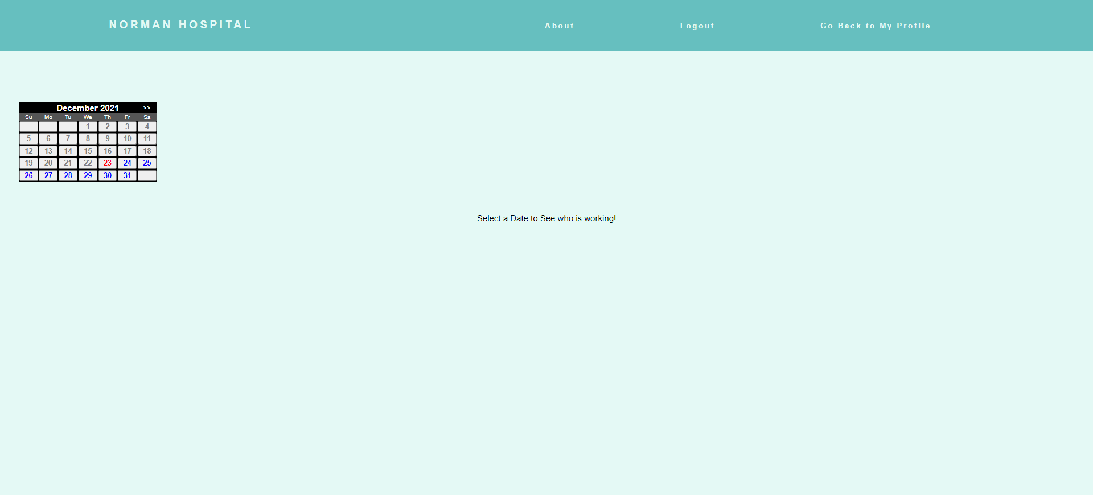

Once a date is selected the shift scedule for that day is displayed.

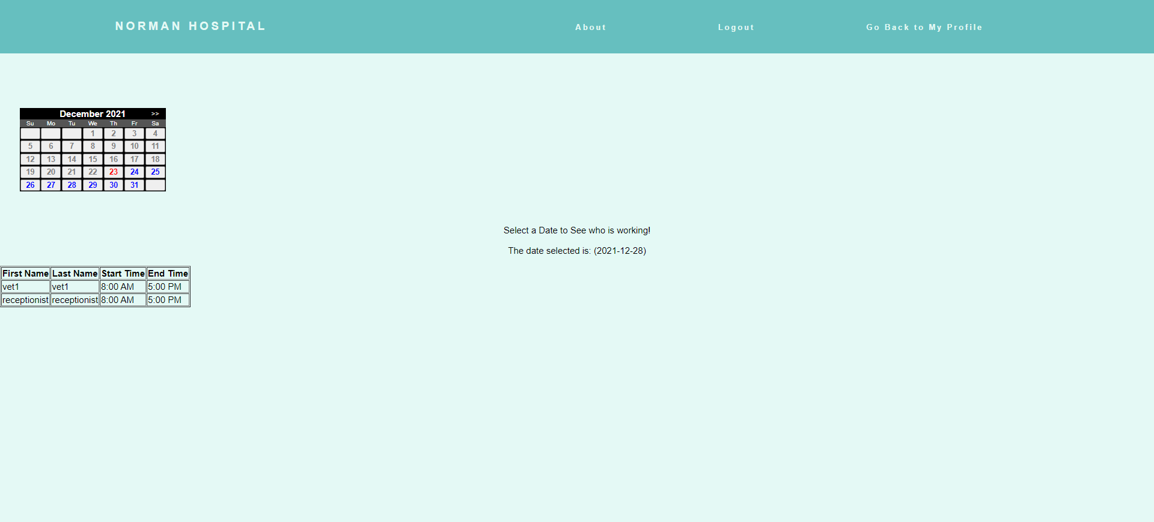

**iv.) View Appointment Schedule Button**

This button redirects the employee to a page where they can view their appointment schedule for a particular date. A date from the calendar can be selected.

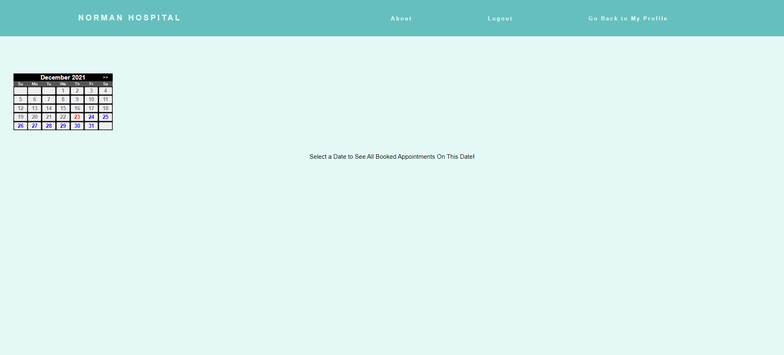

Once a date is selected the appointments scheduled for that day are displayed.

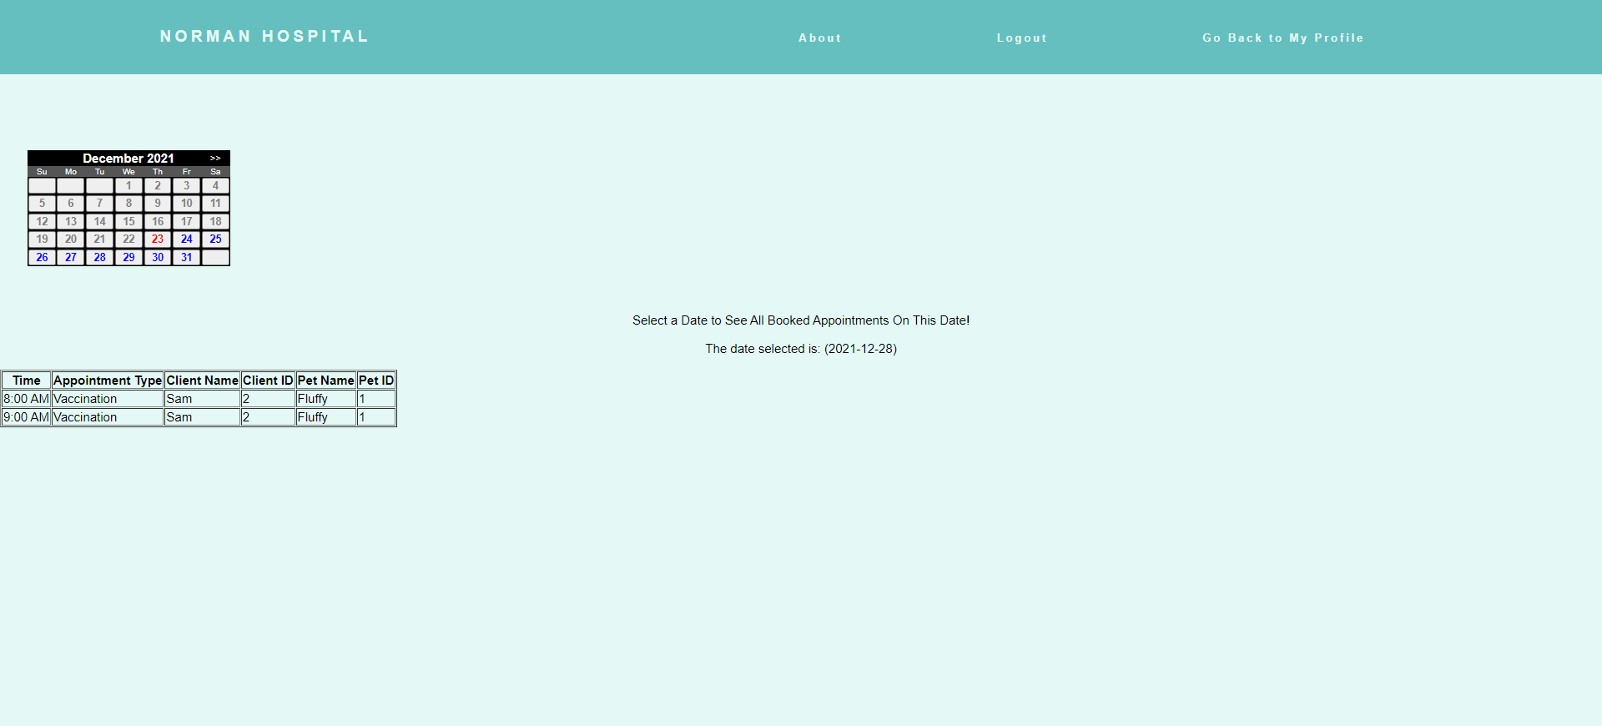

**v.) View Pets Button**

This button is used by the employee to view the pets which are under that particular employee, the medical history for each client can be accessed using the View Medical History Button.

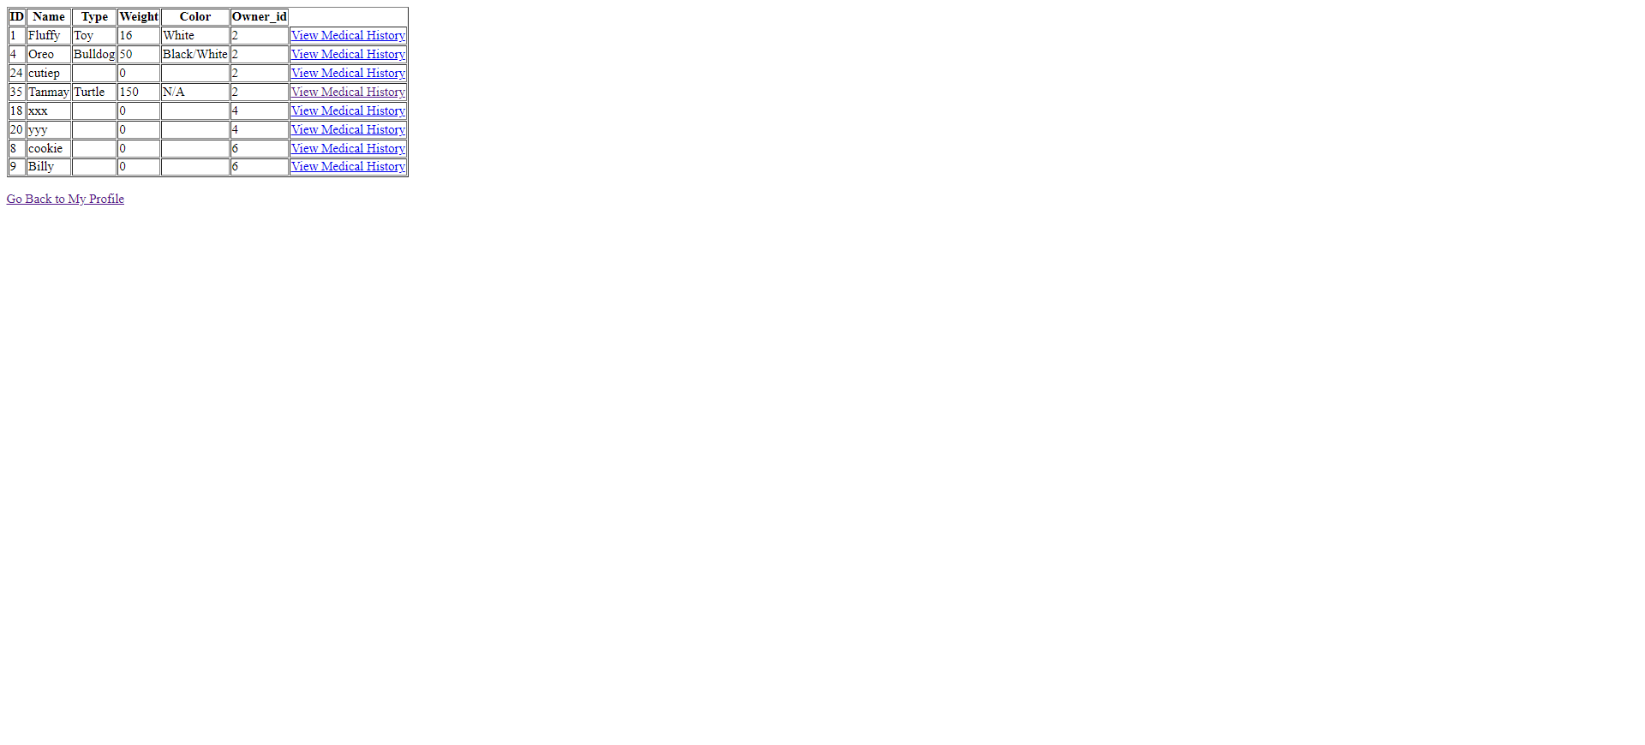

**v.1.) View Medical History Button**

Medical History for each client/pet can be viewed by the employee.

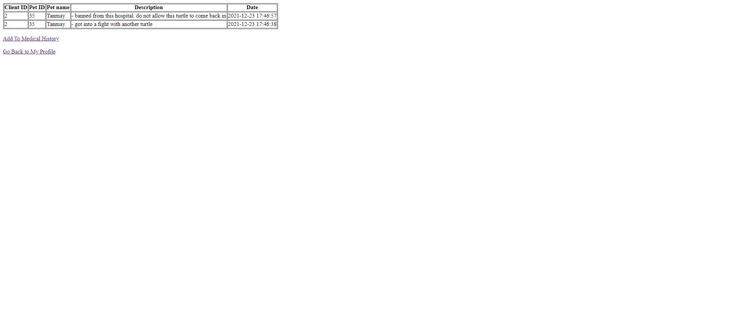

**v.2.) Add To Medical History Button**

The employee can Add medical history for that particular client/pet using this button.

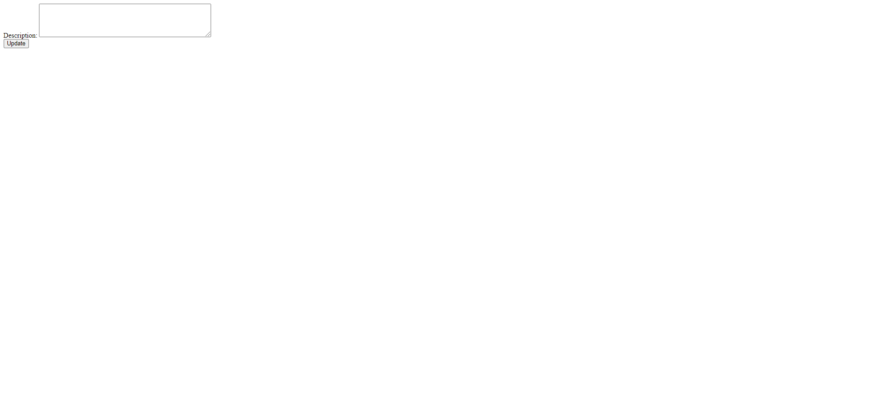

1. **Admin Login**

Admins can log in using the Admin Login page. Admins can log in using their Username and password.

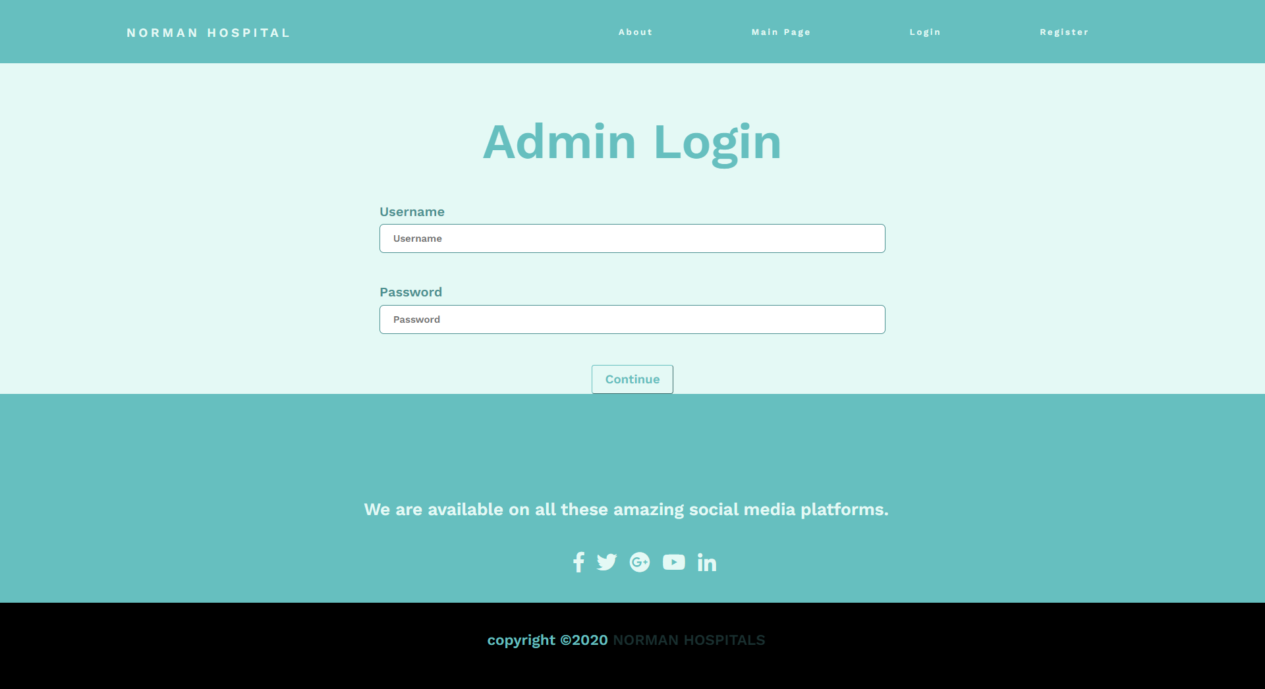

1. **Admin Profile**

When the correct Username and Password for the admin is used, the continue button redirects admin to their profile.

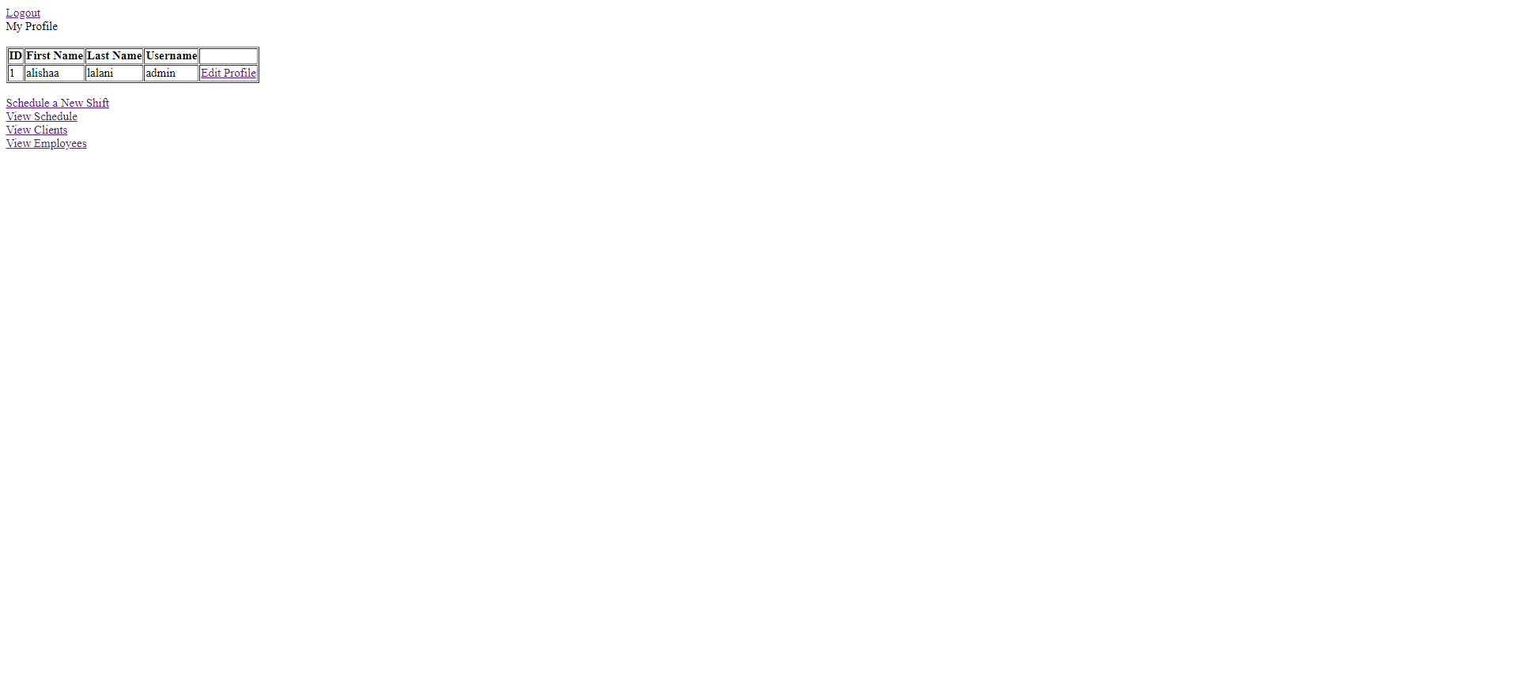

**i.) Edit Profile Button**

This button redirects us to the page where the admin profile can be edited.

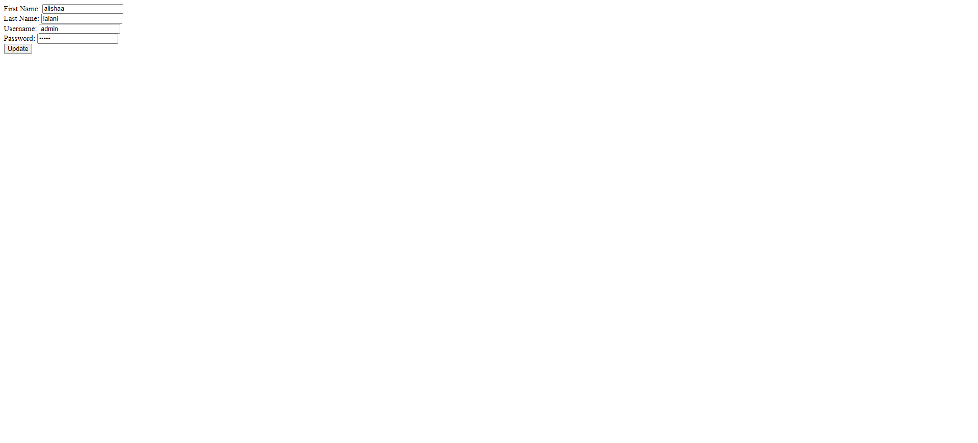

**ii.) Schedule a New Shift Button**

A new shift for a employee can be added, a date from the calender to add the shift can be chosen from the calendar.

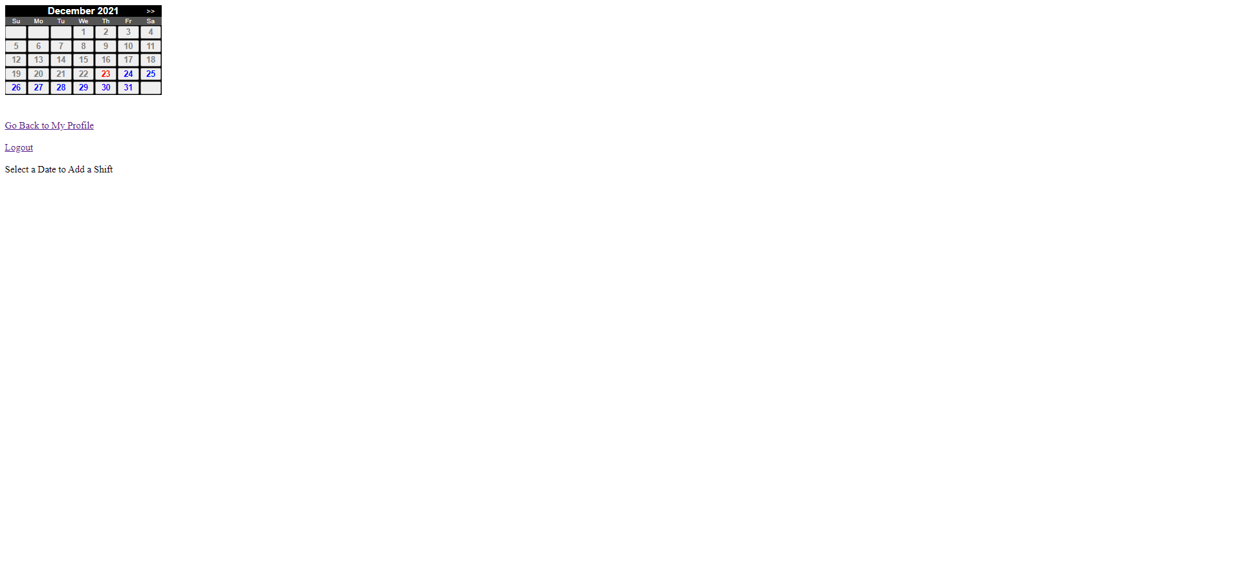

On choosing the date, a time, and the vet, receptionist can be chosen from the drop down menu.

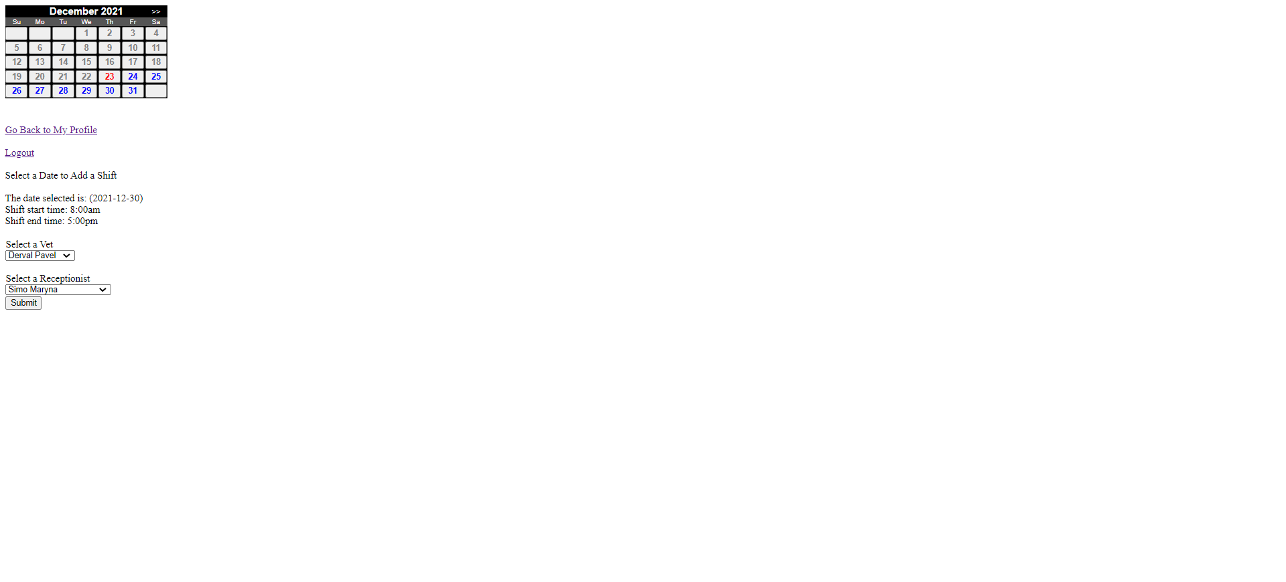

**iii.) View Schedule Button**

This button redirects the admin to a page where they can view the employee appointment schedule for a particular date. A date from the calendar can be selected.



Once a date is selected the appointments scheduled for that day are displayed.



**iv.) View Clients Button**

This button redirects us to the page where details of all the clients can we viewed, the delete button would perform the function of deleting the client information from the database.

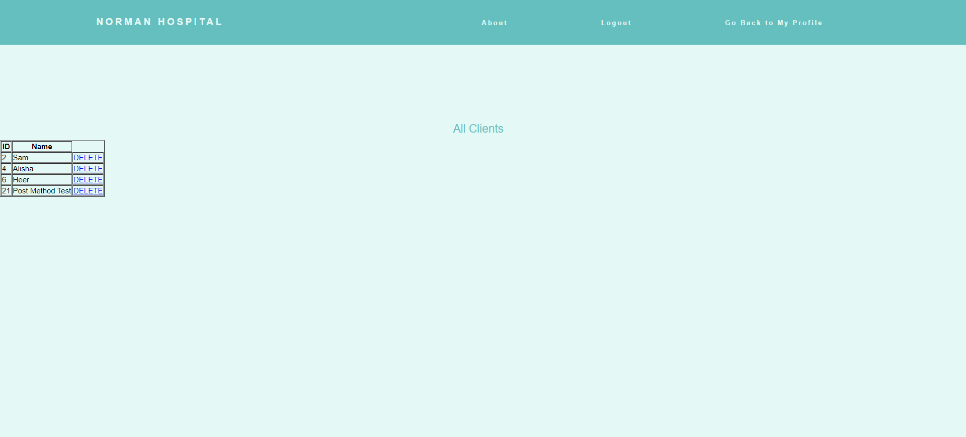

**v.) View Employees Button**

This button redirects to the page where all the employees can be viewed with their details, the delete button can be used to remove the employee from the database.

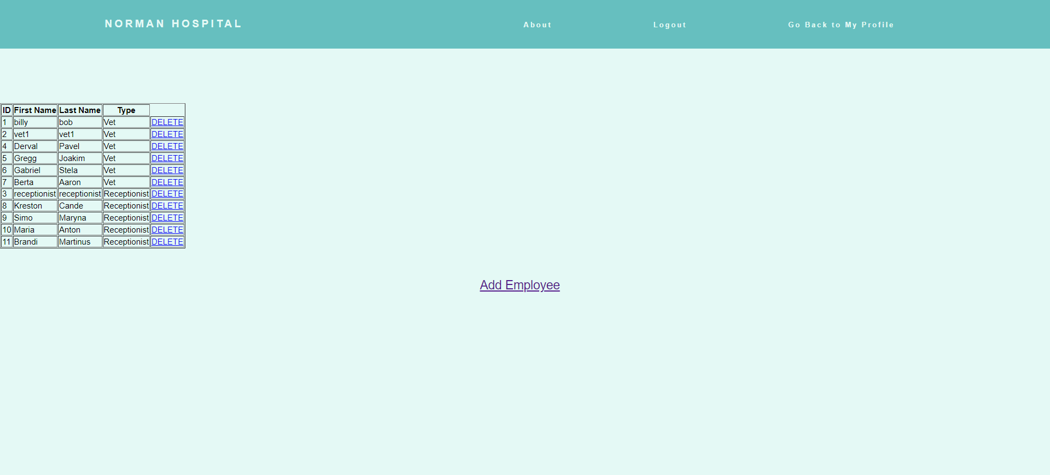

**v.1.) Add Employee Button**

This redirects us to the page where new employees can be added/signed up to the database.

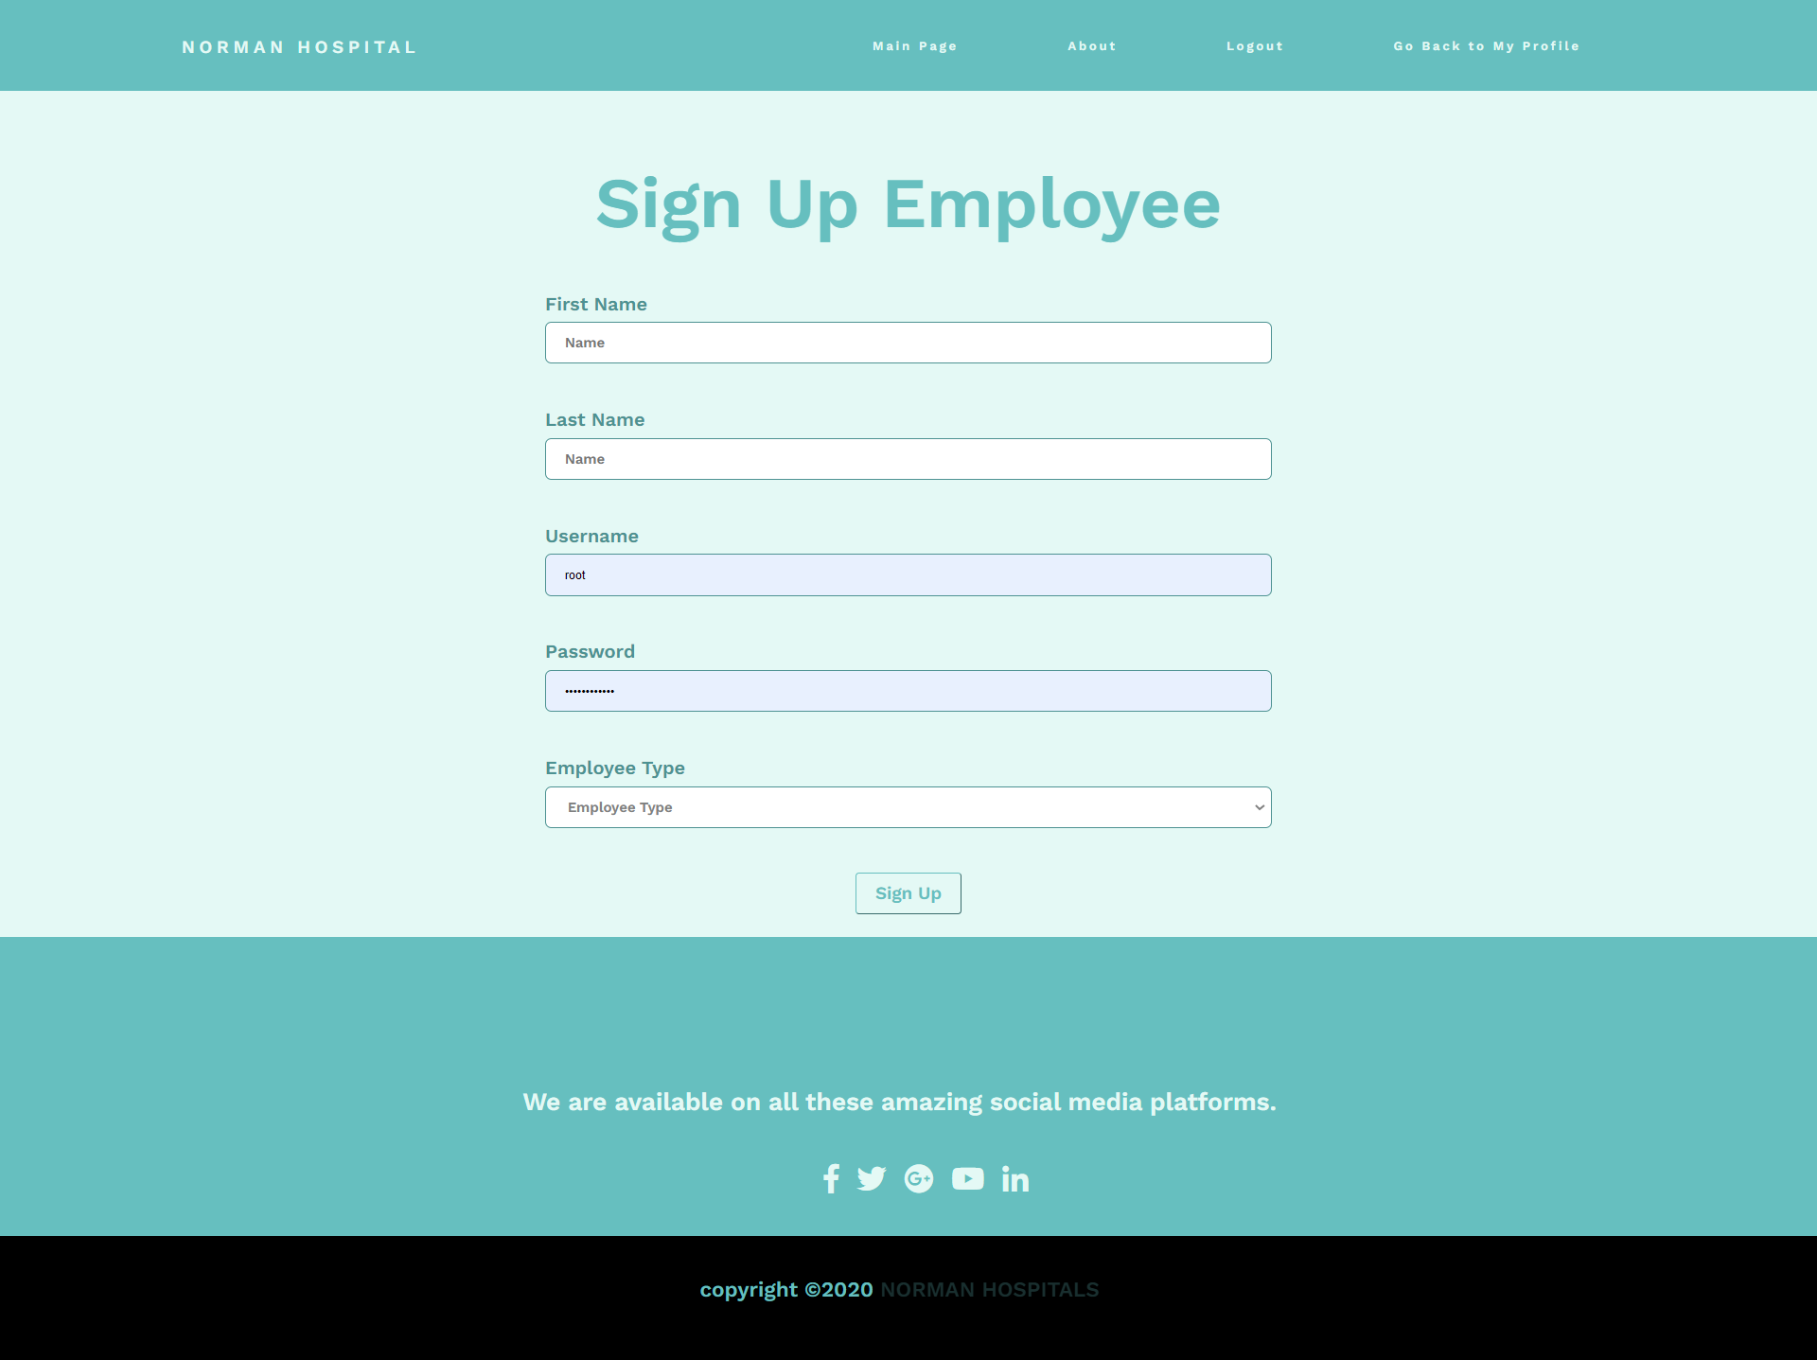

# App

1. Login as a Client

To log in as a client, first open the app. Then, open the menu in the top left corner of the screen:

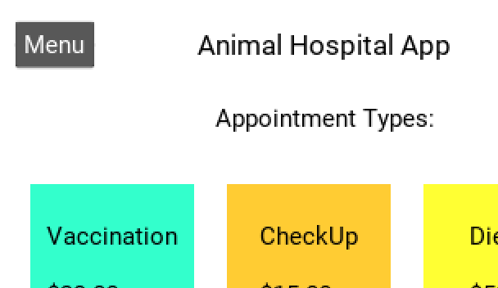

Click on “Client Login”. It will take you to this page:

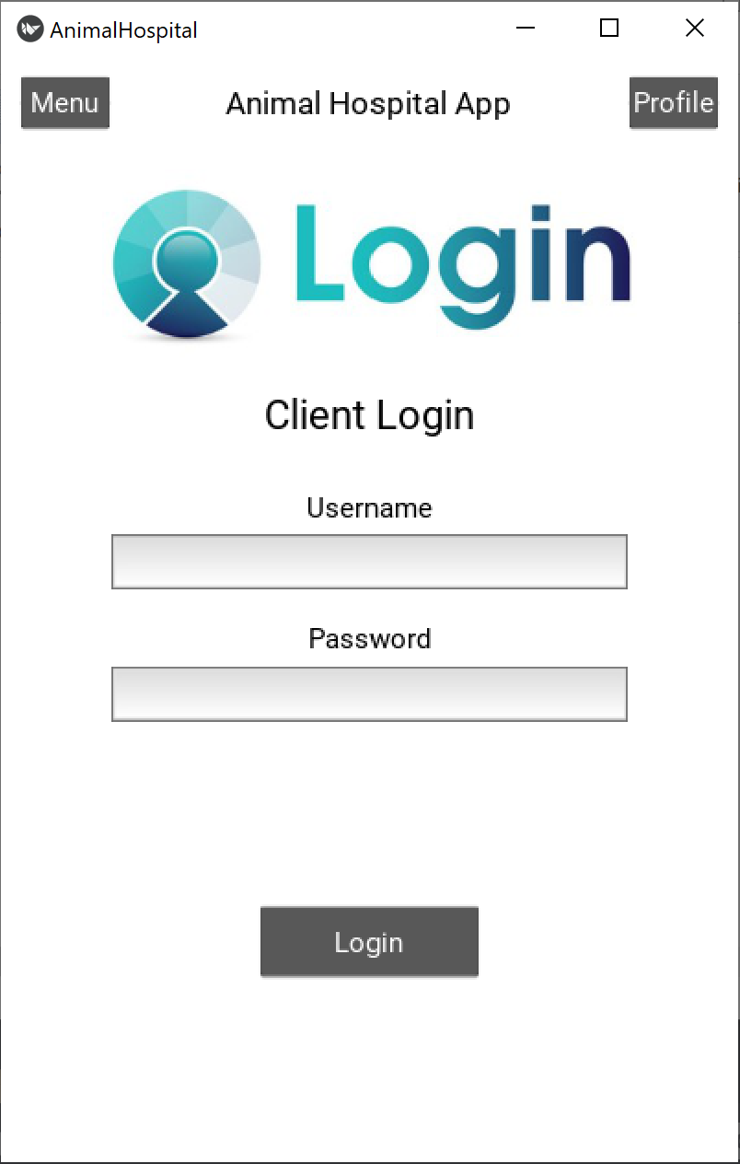

Type in your credentials and click on “Login”. If you have entered valid credentials, you will be brought to your profile page. If not, you will be brought to a page that says “Login Failed” and you must go back to the menu to get to the login page again.

1. View Client Profile

The client profile is opened immediately on logging in, but it can also be accessed via the “Profile” button on most pages in the app:

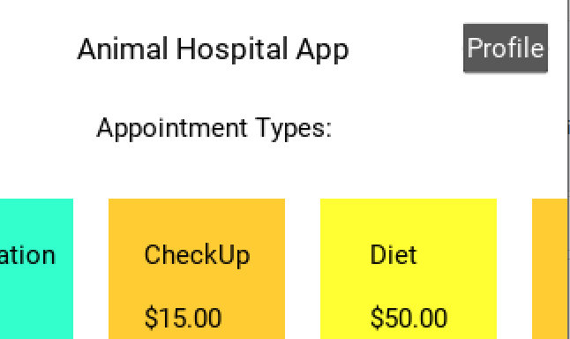

1. Login as an Employee (Vet)

The Vet can login by browsing onto the Vet Login Page and entering valid credentials:

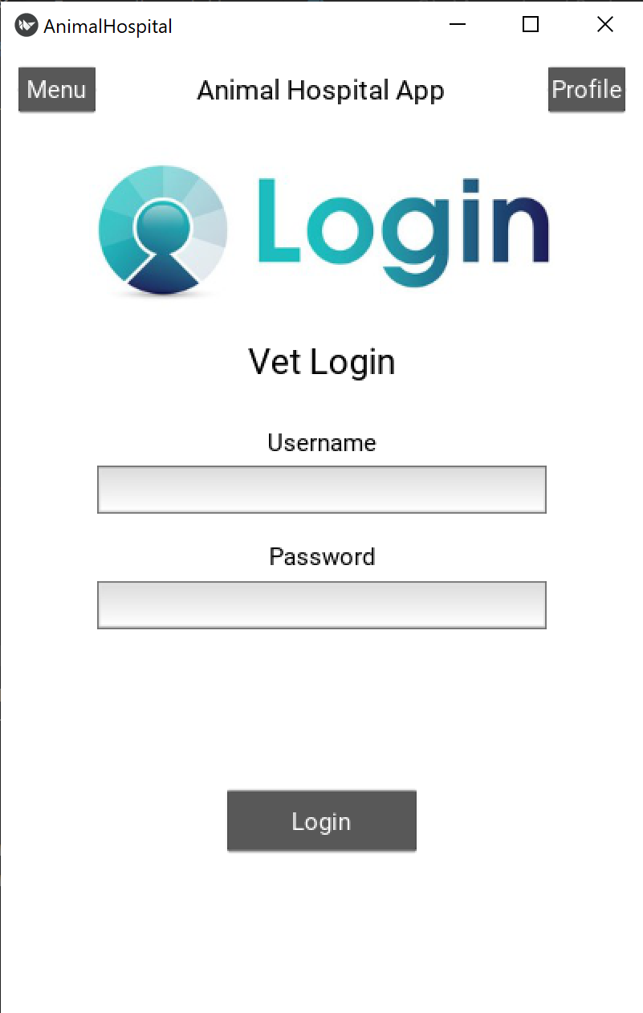

1. View Scheduled Shifts

After logging in, the Vet can see the scheduled shifts:

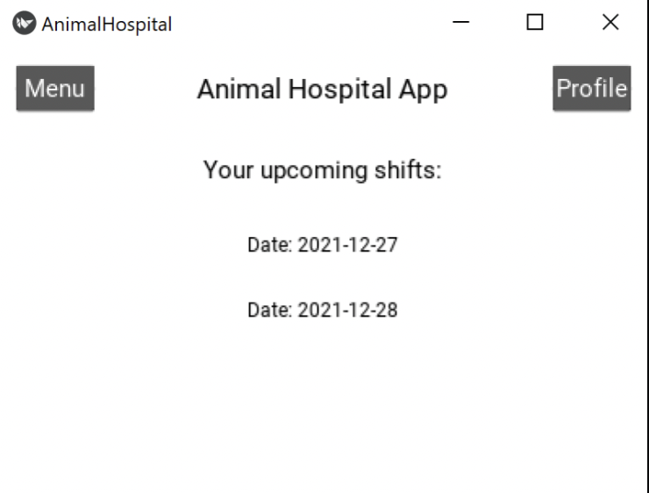

1. Login as Admin

The Admin can login by browsing onto the Admin Login Page and entering valid credentials:

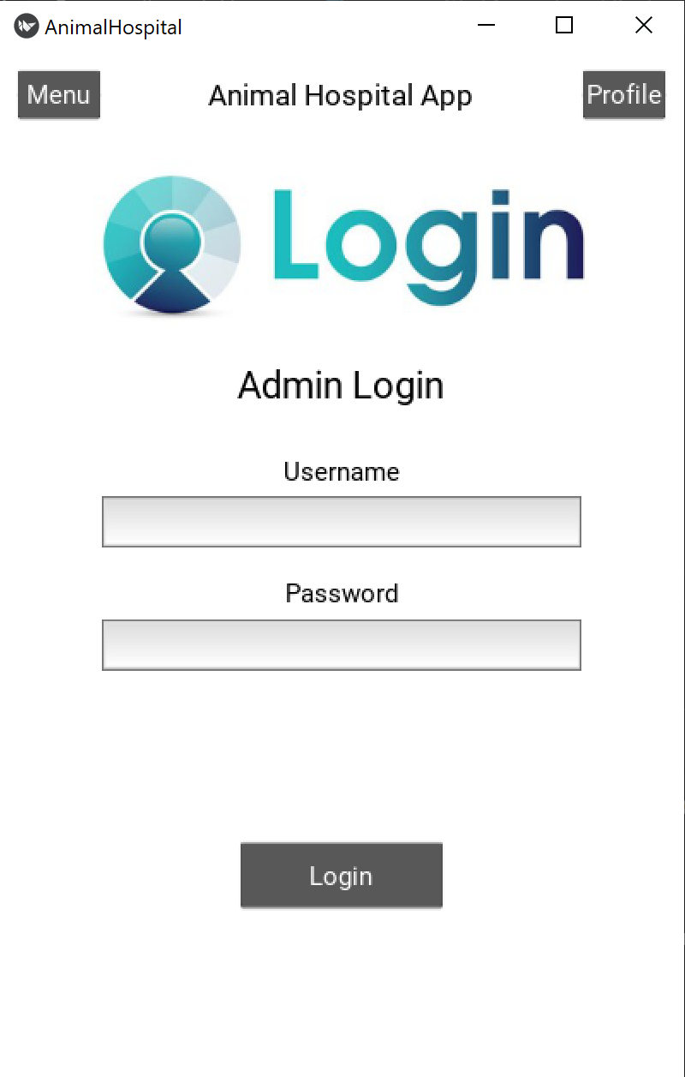

1. Set Shift Schedule

After logging in, the Vet can choose from a whole lot of shifts and dates and then assign a given shift to a particular vet (as described by the screenshots below):

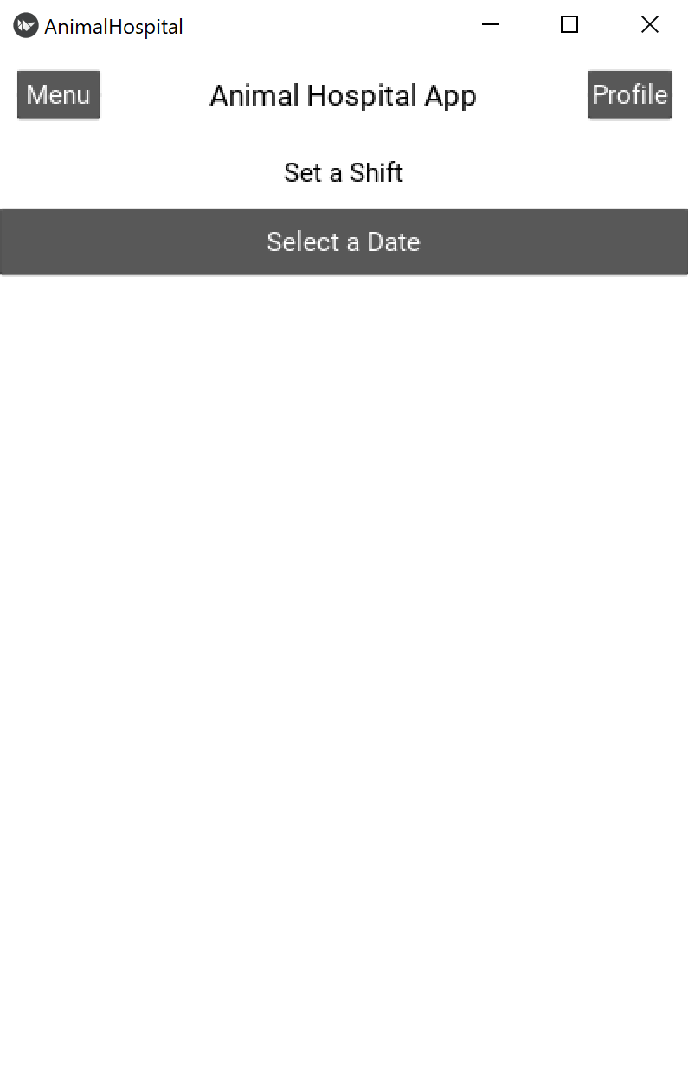

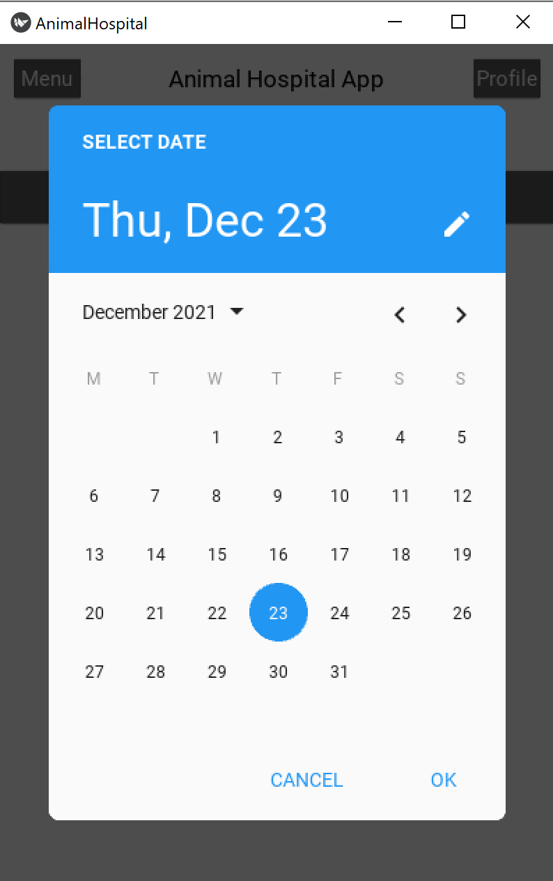

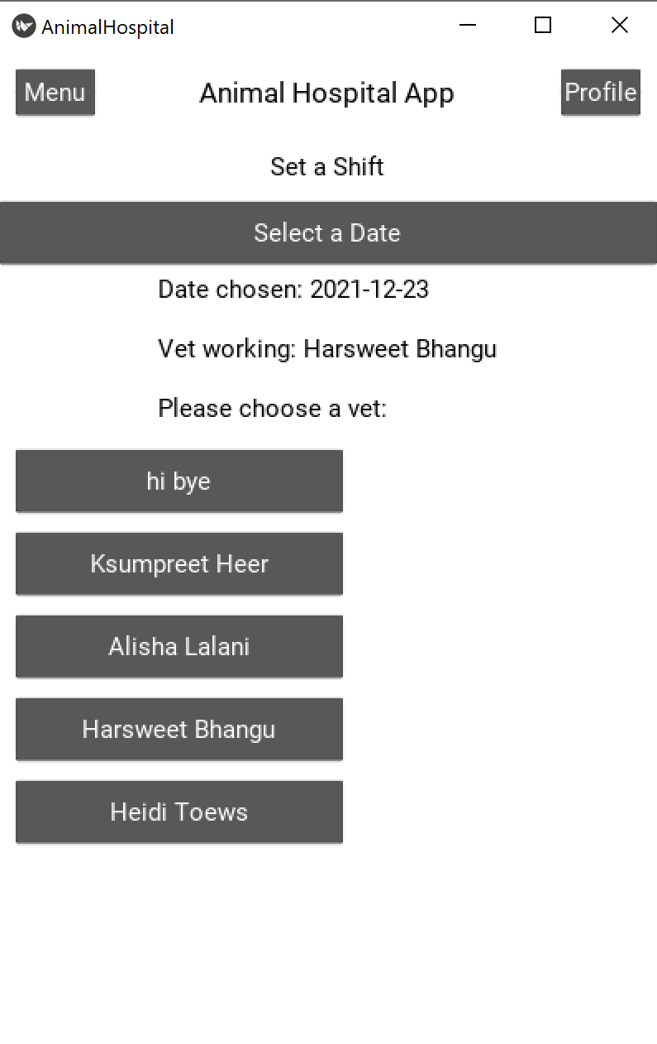

1. Browse to the Pet Store

To see the products in the store, open the menu in the top left corner of the screen:



Click on “Shop”.

You should now see the items available and how much they cost. Note that you must be logged in to add items to your cart for purchase.

1. View Cart

To see the products in your cart, log in and open the shop (see part a for instructions on how to login). Then, click on “View Cart”.

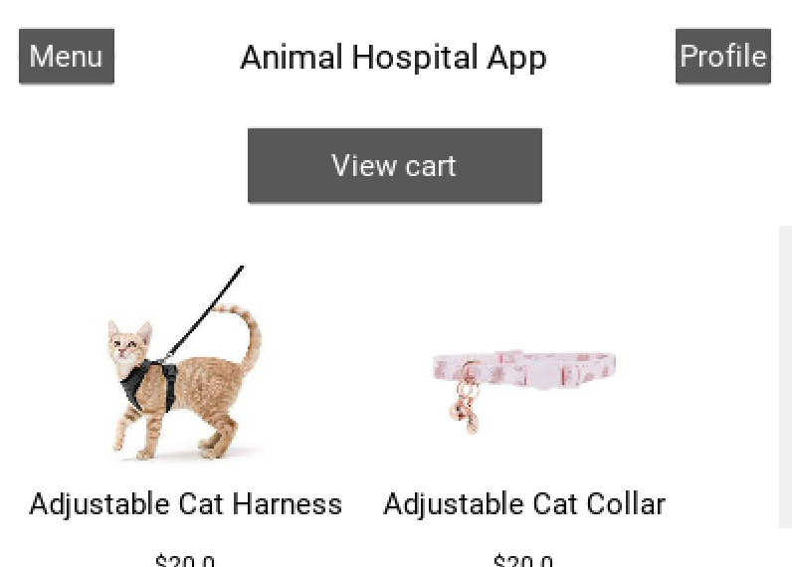

You should see the items in your cart, how much they cost, and how many you have added.

1. Make Order

To order the items in your cart, first navigate to it (see part e for instructions). Then click on “Make order”. You will be taken back to the shop page and your order will be added to your billing history.

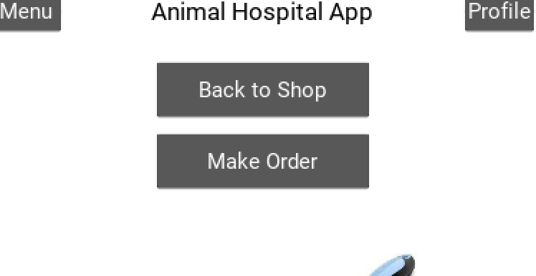

1. Book an appointment

To book an appointment, login and navigate to your profile (see parts a and b for instructions). Click on “Book an Appointment”.

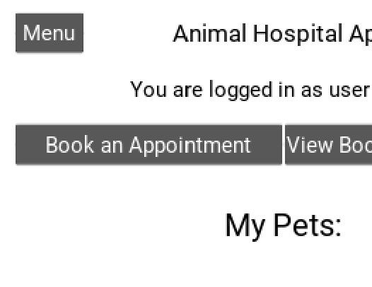

Click on “Select a Date”. A window will pop up, allowing you to select a date.

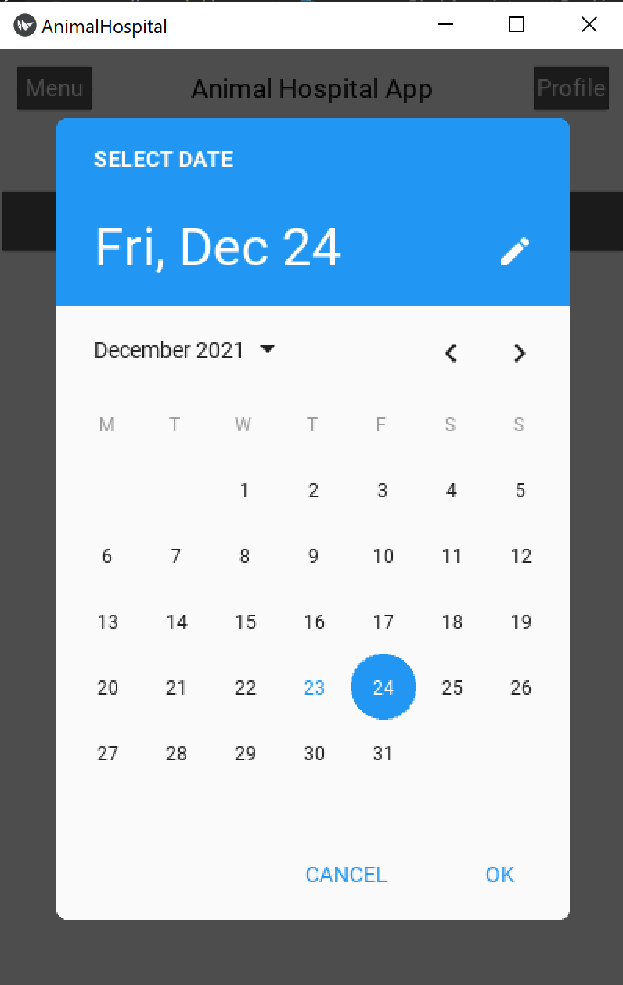

Choose your date and click OK. Buttons will appear beneath the “Book an Appointment” button that are labeled with available appointment times. Click on the time that works for you. You will be brought back to your profile and the appointment will be scheduled in the system.

1. View booked appointments

To view your booked appointments, login and navigate to your profile (see parts a and b for instructions). Click on “View Booked Appointments”.

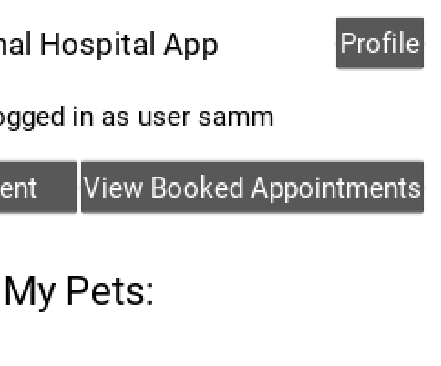

You will see a list of your scheduled appointments with their date and time.

Citation:

# Kusumpreet Kaur Heer(30114618)

YouTube videos used: <https://youtube.com/playlist?list=PLiIaeg66QtXtuJMugrdqxk-lY2icFthLb>

Blog used for blog pages:

<https://www.pethealthnetwork.com/dog-health/dog-diseases-conditions-a-z/5-reasons-test-your-dog-diabetes>

<https://www.pethealthnetwork.com/all-pet-health/should-my-pet-be-tested-covid-19>

<https://www.pethealthnetwork.com/dog-health/dog-behavior/do-dogs-dream>

<https://www.pethealthnetwork.com/cat-health/cat-behavior/do-cats-really-love-you-less-dogs>

<https://www.pethealthnetwork.com/cat-health/cat-surgery-a-z/thyroid-tumor-surgery-cats>

<https://www.pethealthnetwork.com/all-pet-health/small-animal-health-care/choosing-a-veterinary-hospital-your-exotic-pet-5-basic>

Pictures/icons used:

<https://unsplash.com/>

<https://icons8.com/icons/set/dog>